Year 1 home learning
Friday 5th March
Phonics- 20 mins
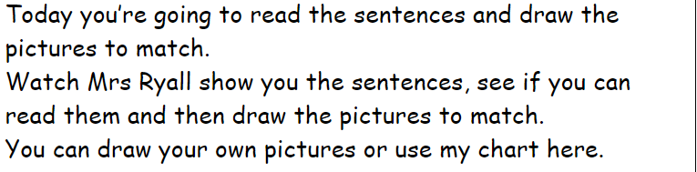
https://www.youtube.com/watch?v=19Jnv9sCo3E

The dog had a thorn in his paw. | I saw a big storm. | I found a dinosaur claw.
The baby could crawl. | A drink with a straw. | A fish jigsaw.

Literacy- 45 mins
Sing the alphabet song.
https://www.youtube.com/watch?v=XCezxDycD80
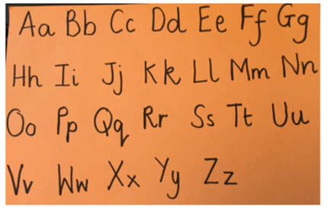
Now practice writing your capital letters.
https://www.youtube.com/watch?v=9xSaINX-fdc

Fairy tale quiz
Can you guess the fairy tale story?
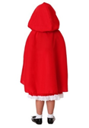
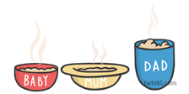
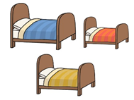

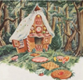
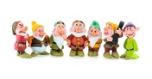
Can you make your own clues for another fairy tale?

Little red riding hood: https://www.youtube.com/watch?v=OScqj-_fm6U
Goldilocks and the three bears: https://www.youtube.com/watch?v=Rm3JsewQIWw
Jack and the bean stalk: https://www.youtube.com/watch?v=XnnSRy3v-1Q
Hansel and Gretel: https://www.youtube.com/watch?v=wDQib9yeEn0
Snow white and the seven dwarfs: https://www.youtube.com/watch?v=NeJSofY7Lzs

Maths- 45 mins
Quick starter!
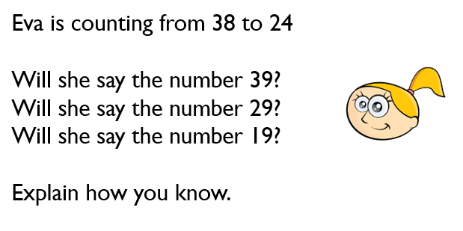

Watch the video in the link below, you will need a pencil and paper to work out some of the problems.

https://vimeo.com/507075995

Now you have a go!
https://resources.whiterosemaths.com/wp-content/uploads/2019/12/Y1-Spring-Block-2-WO9-Count-in-5s-2019.pdf
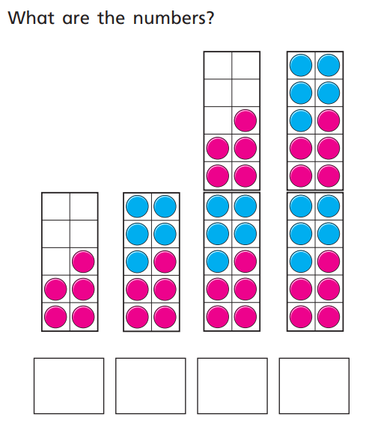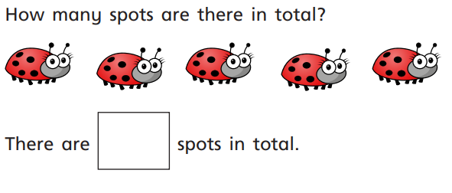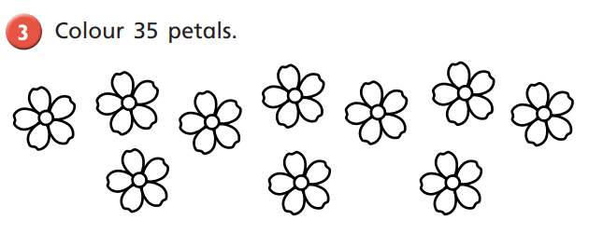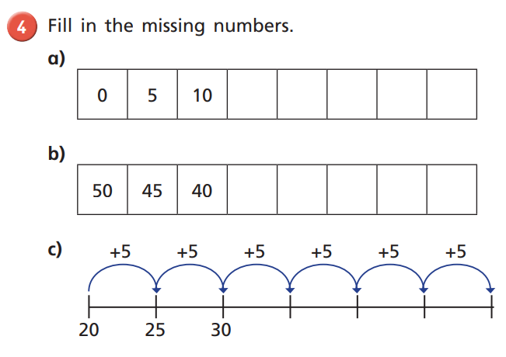

Afternoon learning and activities- about an hour



