Year 1 home learning
Tuesday 9th February
Phonics- 20 mins
Let’s watch Geraldine and see which ie words she can find around her house?

https://www.youtube.com/watch?v=DoPUHeA0CHA

Now we are going on a real and not real word hunt with Mrs Ryall. Here are the words that she has hidden around the room. Remember you are only looking for the real words.
die | tied | fried | briem | tie
lie | cried | grie | zie
clie | stied | pie | tried

Literacy- 45 mins
Let’s practice our one-armed robot letters.
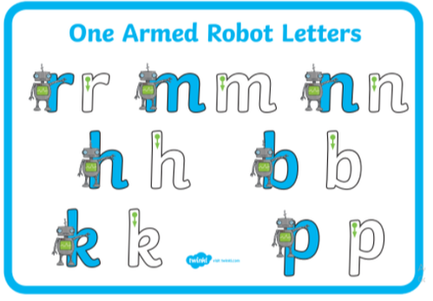
https://youtu.be/HecthNtpJPI

Write a postcard from stickman to his family.

Have you ever been on holiday or a long journey? Well stickman went on an adventure and a very long journey away from the family tree. Sometimes when we go away, we send postcards to our family or friends. Have you ever sent a post card?
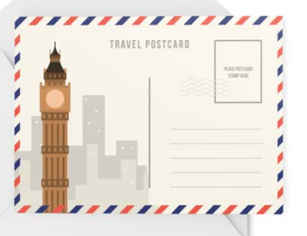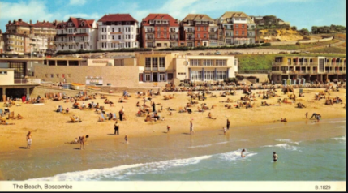

A post card has two sides. One has a photograph or a picture to show where you have been and on the other side there is space for you to write a message and add the persons address.

Have a look at the PowerPoint, all about Post cards.

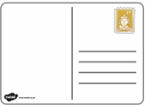

Now you have a go at making a post card. Don’t forget that it is from Stickman and not you! What do you think the picture will be on the front? What will Stickman talk about on his postcard?

Draw a picture of a scene from stickman. Then write a short message to Stick Lady love and his children three. Will Stickman be happy, sad or angry? Can you come up with an address for the family tree with your grown-ups!

Maths- 45 mins
Quick starter!
Which one is the odd one out? Why?

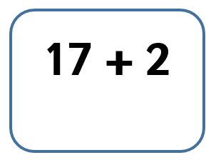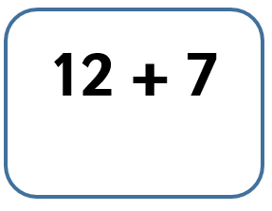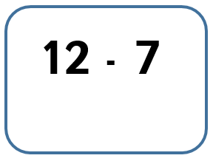

Watch the video in the link below. You will need a pencil and some paper to work out some of the problems.

https://vimeo.com/503093120

Now you have a go!
https://resources.whiterosemaths.com/wp-content/uploads/2019/12/Y1-Spring-Block-2-WO4-One-more-one-less-2019.pdf
Use pasta, cereal, small toys to make each number
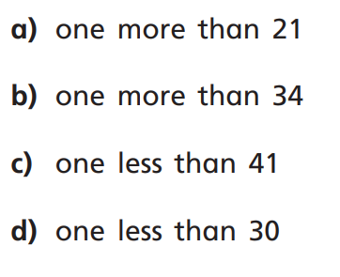

Can you make one more or one less with different numbers?

Afternoon learning and activities- about an hour
Science
Yesterday you had a look at some animals and sorted them into some groups. This is called classification. All animals can be sorted into groups. Here are the groups that all the creatures can be sorted into.
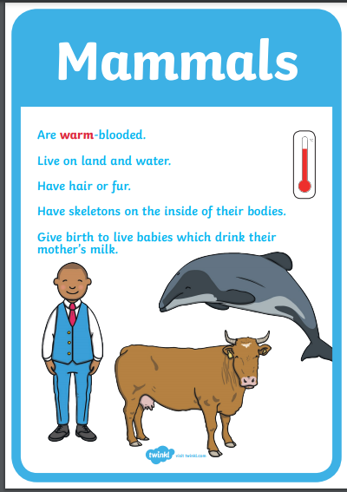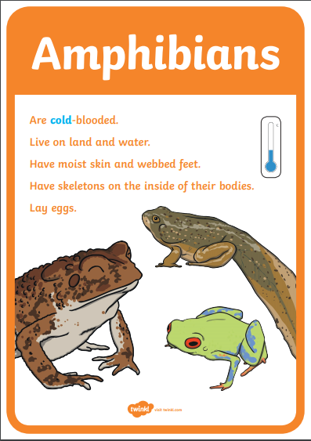

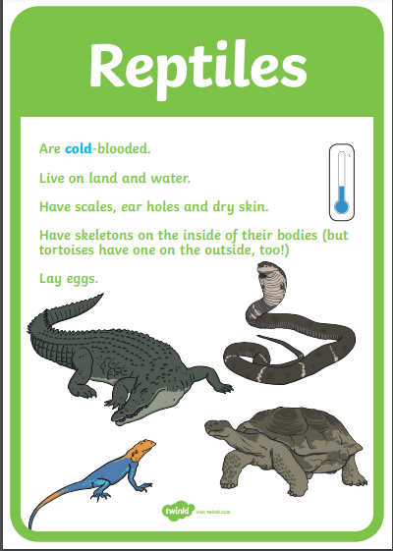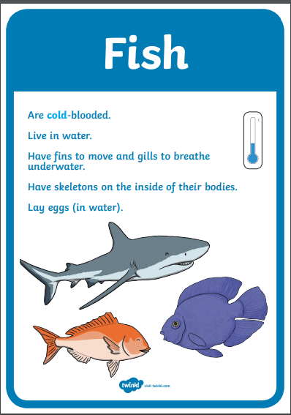

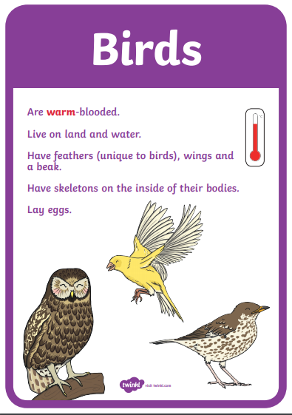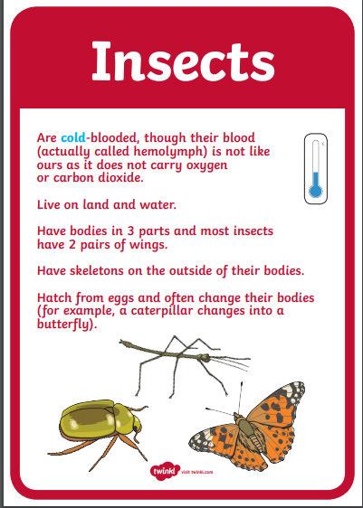

Now look at all these woodland animals. Can you sort them all into the right groups?
You could write the names of the animals or draw a picture of them in the right group.
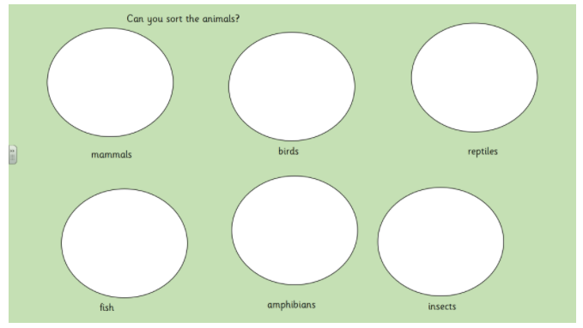
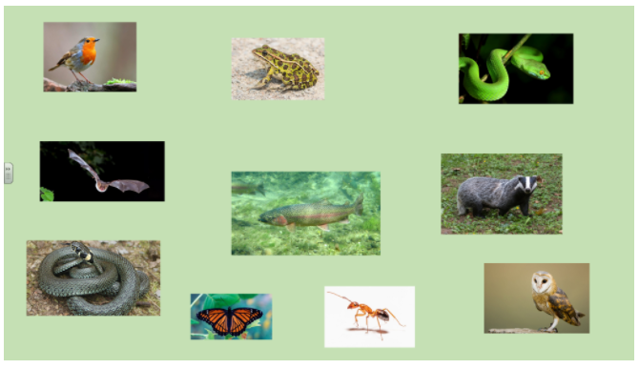

PE
Let’s get moving!
Look for the icon below on the Year 1 home learning page and choose one of your favourites. Cosmic yoga, PE with Joe Wicks, Just Dance or Go Noodle. Make sure you warm up first and then have some fun!



