Year 1 home learning
Wednesday 27th January
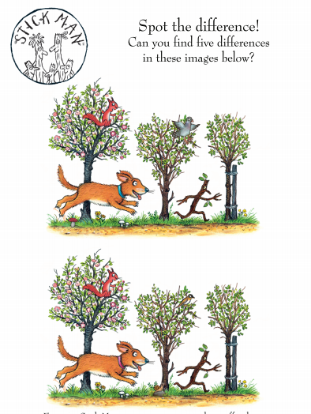

Phonics- 20 mins
Mrs Matthews has made some videos of our ‘ai’ and ‘ay’ phonemes. Have a good look at the videos because tomorrow all of these words are going to be mixed up and you will have to sort them out!

https://www.youtube.com/watch?v=5MrANMxQcZM

https://www.youtube.com/watch?v=FoSOtvnB3KI

Okay are you ready to play bingo? You will need the words that you found around Mrs Paxtons living room yesterday and write them on a bingo card.
A bingo card looks like this:

On your bingo card you need to write 6 of the words that we found (you should have found 8). When you are ready, play Mrs Paxtons video as she is the bingo caller. Use a pen to cross out the words when Mrs Paxton calls them out. Don’t forget to shout BINGO when all your words have been crossed out. Good luck everyone!

https://www.youtube.com/watch?v=AZmzUZmSVig

Literacy- 45 mins
Who am I?
We now know so much about the Stickman story, I wonder if we can write some character descriptions! Think carefully about all the characters in the story (we did some work on this on Monday!) What you need to do is write 3 or 4 clues about one of the characters in the story, without writing who it is you are writing about.
We are going to see if your grown-ups can guess who you have written about!

Use the colourful semantics to help you.

Who? | have | What?
I | have | 

Who? | am | Where?
I | am | 

I have children.
I have a spade in my hand.
I am wearing shorts.
I am at the beach.
Who am I?
Who have I written about? Can you guess?

Maths- 45 mins
Quick starter?
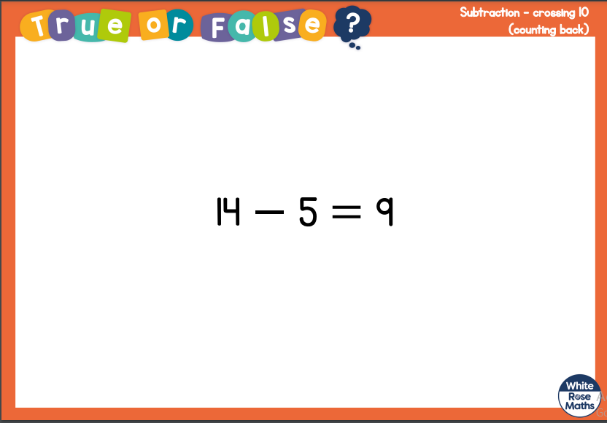

Watch the video in the link below. You will need a pencil and some paper to work out some of the problems.

https://vimeo.com/497563367

Now have a go!
https://resources.whiterosemaths.com/wp-content/uploads/2020/12/Y1-Spring-Block-1-WO-Subtraction-crossing-10-counting-back-2020.pdf

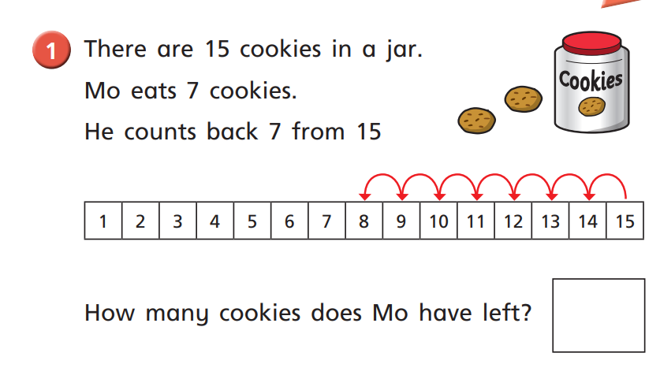

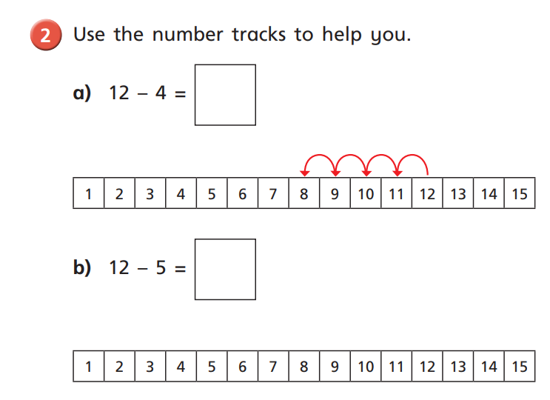
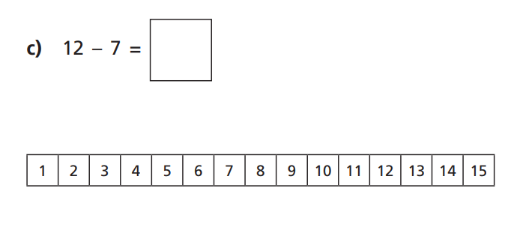

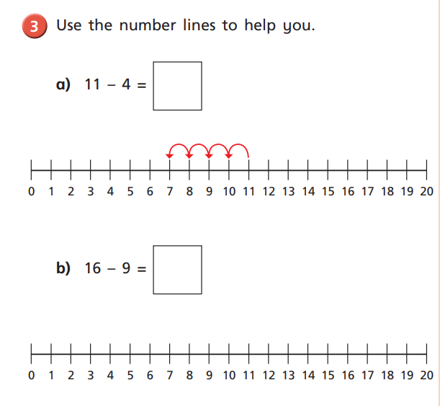
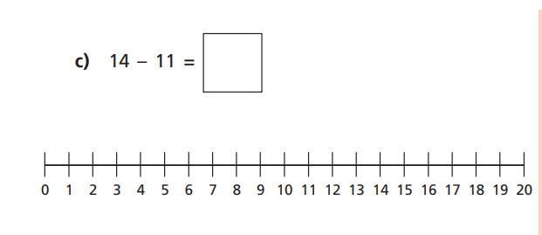

Challenge!
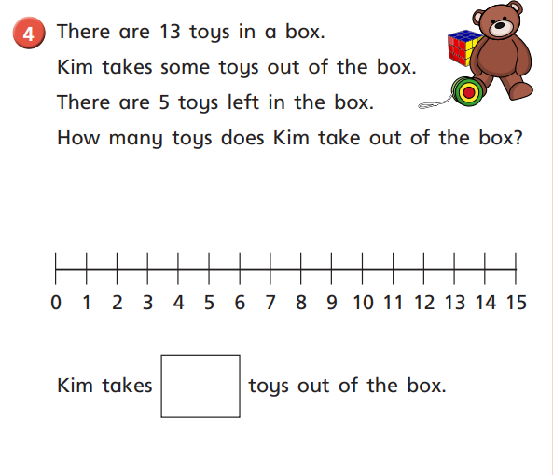

Afternoon learning and activities- about an hour
PSHE
Last week we thought all about caring for animals. Today we are going to think about how we care for our families.
Listen to the story ‘’Sharing a shell’’ read by Mrs Ryall.
In this story the creatures work together to create a happy place to live. They each help the other out by doing different jobs and taking care of each other.

https://www.youtube.com/watch?v=5XQWU_HUd2I

Now I want you to think about how you care for people that you live with. Do you help out doing jobs around the house? Do you have younger brothers or sisters that you play with? Do you always remember to say thank you when someone does something for you? We can show our families that we care in lots of different ways.

Now I want you to have a go at making a paper family. Watch the video and follow the instructions.

https://www.youtube.com/watch?v=rMSY6deAn1U

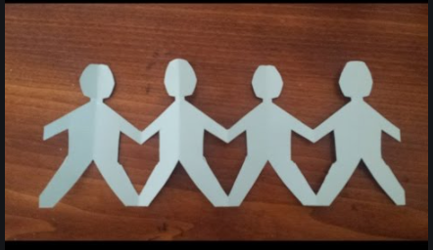

Decorate your people, make them look like the people in your family. Think about how you care for the people in your house.

PE
Let’s get moving!
Look for the icon below on the Year 1 home learning page and choose one of your favourites. Cosmic yoga, PE with Joe Wicks, Just Dance or Go Noodle. Make sure you warm up first and then have some fun!



