Year 1 home learning
Wednesday 24rd February

Phonics- 20 mins
Play Forest Phonics to practice the phase 5 ou sound.

https://www.ictgames.com/mobilePage/forestPhonics/index.html

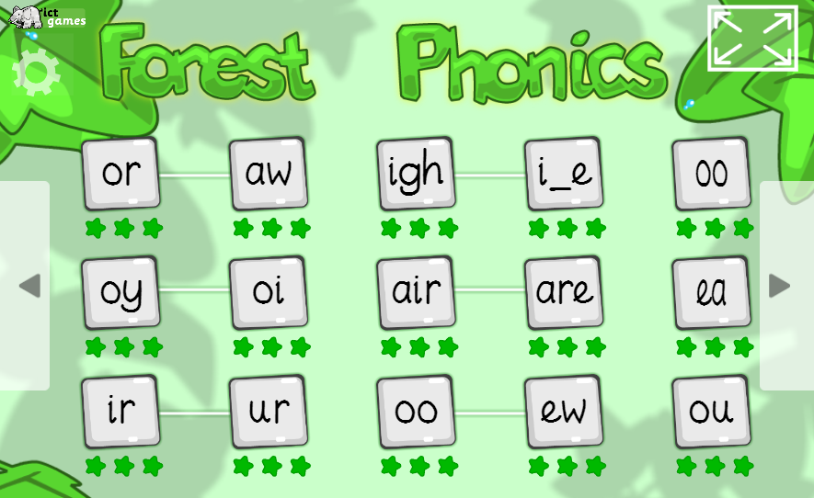

Real or not real? Watch this video and see if you help Mrs Ryall find all the real ow and ou words hidden around the room.

https://www.youtube.com/watch?v=epYrh2Ilo90

Literacy- 45 mins
Practise your one-armed robot letters.
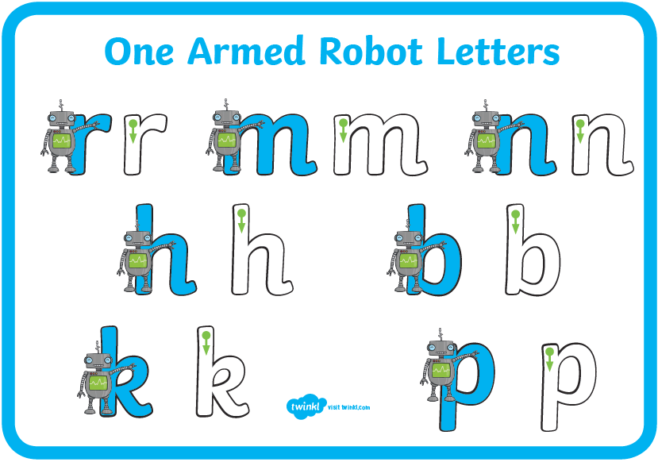

Let’s have a look at the title of the story and the author with Mrs Paxton. Watch her video to find out what the next task will be for literacy.

https://www.youtube.com/watch?v=HomFE9fRV1w

Can you think of a time that you were woken in the night by a storm? Or being woken in the night by unusual noises. How do you think the boy is feeling? Look at his facial expressions.
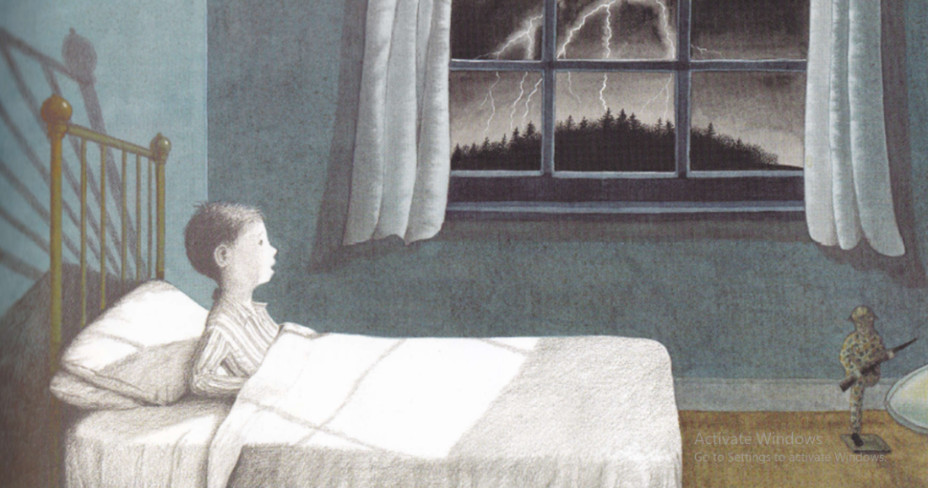

Is there anything unusual or strange in the picture? Imagine you are the boy, what might the terrible sound be? What sound do you think wakes the boy?
Remember to think about those posh ‘Onomatopoeia’ words. (These are words that describe a sound, for example: The “boom” of a firework exploding, the “tick tock” of a clock, and the “ding dong” of a doorbell.

Can you think of some more sounds that the storm might make? Why don’t you make some like the examples above?

Watch this short video of a thunder storm. Listen carefully to the sounds that you hear.
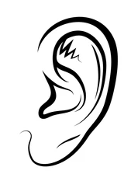

Now it’s time for you to recreate the sounds of the storm. You could use your body to create sounds, your voices to shout out those onomatopoeia words you thought about or use objects in your home. Why don’t you record the sounds and play it back so you can hear the thunderstorm that you created! Look at this video for some ideas.

https://www.youtube.com/watch?v=Bjm88uNbnxA&list=RDBjm88uNbnxA&start_radio=1&t=101

Maths- 45 mins
Quick starter
Play this game to practice pairs of numbers that make 10, if you want a challenge try finding pairs that make 20.

https://www.topmarks.co.uk/maths-games/hit-the-button

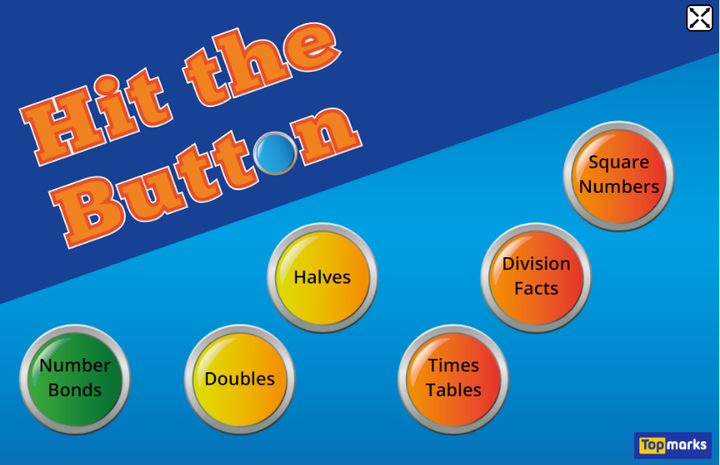

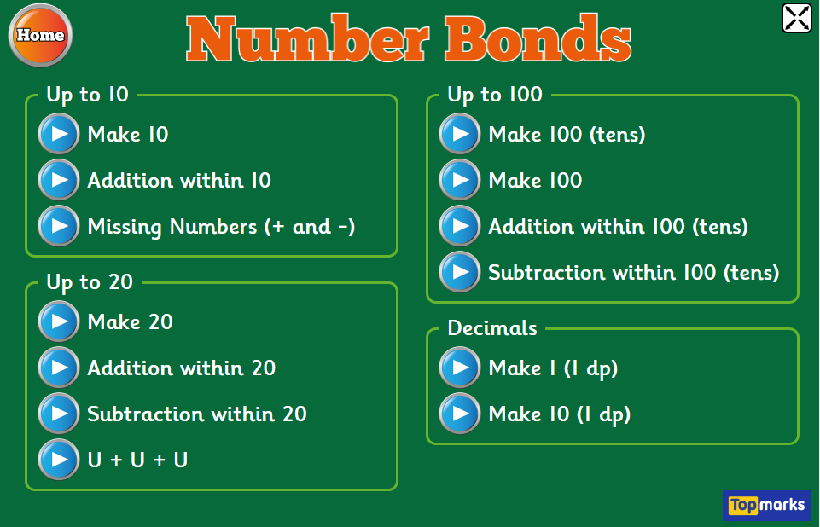

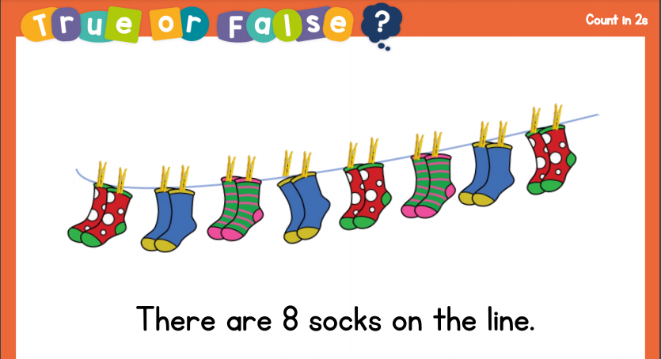

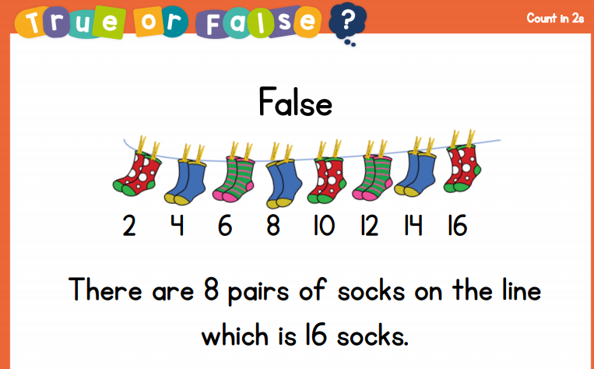

Did you get it right?

Watch Mrs Ryall and see if she can count in twos correctly!

https://www.youtube.com/watch?v=piQehlUCokg

Afternoon learning and activities- about an hour
PSHE
In our next PSHE sessions we are going to be thinking about our strengths. We are all different and have different strengths. We want to know all about what makes you so amazing!

Listen to the story of The Hueys in the new jumper. All the Hueys wanted to be the same, look the same, think the same and dress the same. It would be very boring if we did that! We want to celebrate how great it is that we are all different and special just as we are.

https://www.youtube.com/watch?v=Bmry14iqC7E

We think that you are all brilliant and know that you are all great at different things. We’d like you to design a jumper that you could wear to show all the things that make you special. You could draw on it things that you are good at, things you like to eat, what you like to play and any special skills you have. You might be a fantastic baker or a great footballer.



