Year 1 home learning
Thursday
Phonics- 20 mins
Read the correct oy sound: http://www.ictgames.com/dinosaurEggs_phonics/

Model writing the words join, boil, coin, foil, coil, soil, point, toy, boy, joy, oyster, enjoy on a piece of paper. Challenge your child to see if they can write the word correctly before you do. Focus on correct letter formation.

Now choose 4 words and write them on a bingo board. Call out the words and cross them off. Who will shout bingo first?

Literacy- 45 mins
https://www.youtube.com/watch?v=jwqxd4SfNcw

Infer- I’m thinking about the stick we had yesterday. Now we found our stick in our garden / at the park/ on the grass but I wonder where else we might find a stick? Maybe in the woods, on a mountain or at the beach. What would be around the stick? A bench? A tree? A park? Some flowers? Some snow?

Grammar and Punctuation teaching- things I can touch are called nouns.

Take a walk around your house or garden. Draw 10 different nouns and label them. Can you describe what you have found? Can your grown up guess what you are describing?

Independent work- Create: Draw a picture/create with paint/make a model showing the surrounding area where the stick was found. Label the nouns. How am you going to attach the stick to the paper? Be as creative as you like.

Maths- 45 mins
We’ve done lots of work with numbers within 10. Reading and writing them and adding and subtracting within 10. It’s now time to work with numbers we call teen numbers. The numbers between 10 and 20. The next few sessions will work on this.
Watch the video in the link below. Like yesterday you will need a pencil and paper to write down answers to the questions.

https://whiterosemaths.com/homelearning/year-1/week-11-number-place-value-within-20/

On paper can you write these numbers in words? Get a grown up to check you’ve got it right.

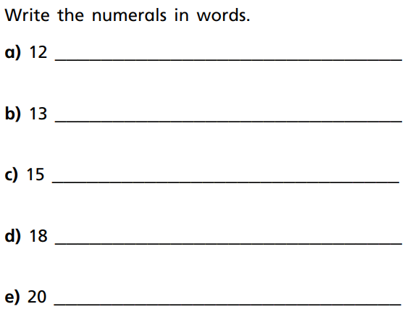

Ask you grown up to draw you these number tracks. Can you fill in the missing numbers? Make sure your numbers are the right way round!

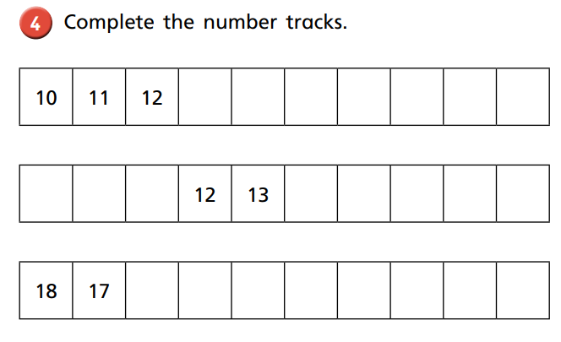

Maybe now you could write all the number from 10-20 on pieces of paper, take it in turn to muddle them up. Who can put them back into the right order the quickest? Use a timer to see ow quickly you can do it. Get your grown up to hide one of the numbers, can you spot which one is missing?

Afternoon learning and activities- about an hour
Today it’s time to find out a bit more about one of the 4 countries of the United Kingdom- Scotland.
Have a look at the power point below.

Hopefully now you know a lot more about Scotland. Did you find out the name of the special material that some Scottish clothes are made from?
We thought you could have a go at weaving your own tartan out of paper. You will need a larger piece of paper and some strips of paper. This could be any paper you can find at home, even newspaper.

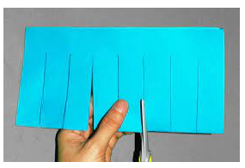
First fold your larger piece of paper in half and cut from the fold to nearly the top.
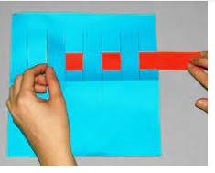
Open out the larger piece and start weaving your strips through.
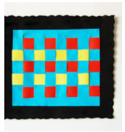
Now you’ll have a lovely piece of ‘tartan’

Now if you want to have a go at making the national flower of Scotland, take a look at Miss Sleem’s video.

https://youtu.be/t9vxKqWkI8o

