Year 1 home learning
Monday 25th January
Phonics- 20 mins
It’s Monday again so we are learning a new phoneme. This week we are looking at the phase 3 ‘ai’ and phase 5 ‘ay’. The phase 5 ‘ay’ lives at the end of a word.

Watch Geraldine learn the ‘ay’ phoneme. Can you think of any other words that have the ‘ay’ sound?

https://www.youtube.com/watch?v=MTCP8i4Nwgc

The days of the week have the ‘ay’ digraph. Let’s make a game with the days of the week! We are going to play snap! First you need to write out the days of the week twice. Then share the cards with you partner and play snap – don't forget to shout SNAP if you have found the same day.

Monday Tuesday
Wednesday Thursday Friday
Saturday Sunday

Can you remember our days of the week song? Maybe you could sing it to someone at home and teach them it!

Now have a practice at writing your capital letters
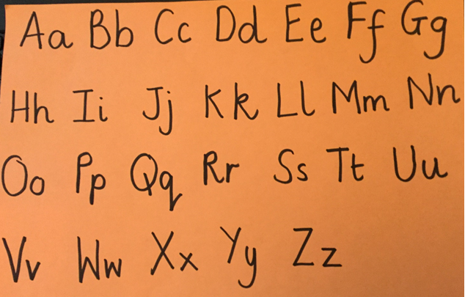

You will need a pen or pencil for this and some paper.
Watch the video and write the alphabet as it plays.

https://www.youtube.com/watch?v=9xSaINX-fdc

Literacy- 45 mins
Let’s look at all the characters in the story.
Stickman 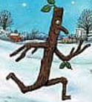 | Stickmans family  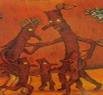 | Dog 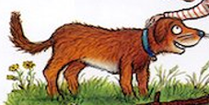
Girl 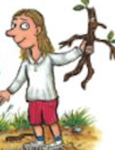 | Swan 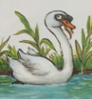 | Dad 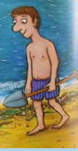
Boy 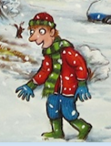 | Father Christmas  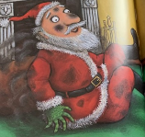 | Family  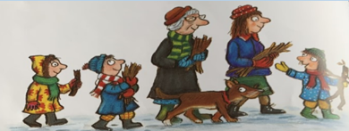
Task 1: Draw pictures of the characters.
These are all nouns. I wonder if we could add some descriptions for our characters using noun phrases e.g., Red coat, brown bark.

Task 2: Write short sentences for the different characters. Think of some adjectives to go with the nouns: e.g., long spikey arms, sharp white teeth, long thin neck.

Purpose: to add detail and description in their writing.

Maths- 45 mins
Quick starter!
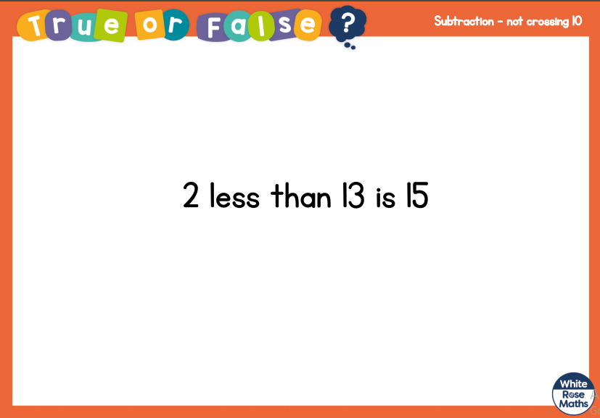

Watch the video in the link below. You will need a pencil and some paper to work out some of the problems.

https://vimeo.com/492197096

Now you have a go!
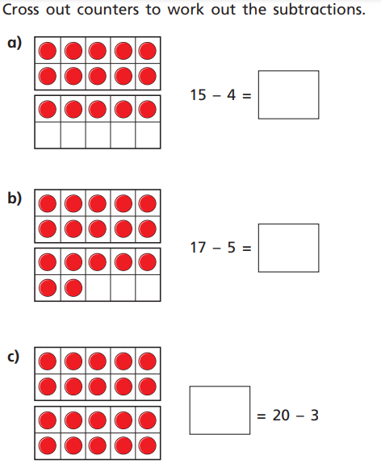

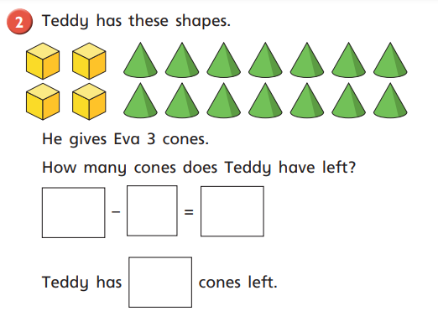

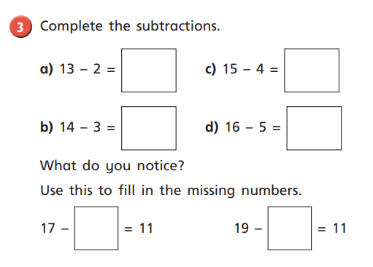

Afternoon learning and activities- about an hour
Science

Watch the video. How do we know that it is winter in the story? What clues can we see?
https://www.youtube.com/watch?v=c0YjhXnta14&feature=emb_title
While your Stickman is freezing why don’t you watch Kit and Pup and find out about melting and freezing.

https://www.bbc.co.uk/iplayer/episode/b0bf5g0v/kit-pup-series-1-23-melting-and-freezing

Task 1:
Now it’s time to do a science experiment.
You will need; -
The ice cubes you froze last week
Tablespoon salt
Tablespoon sugar
Tablespoon flour

Make a prediction (guess) which ice cube will melt the fastest.
Place each ice cube onto a plate and label these 1-4.
On plate one place one ice cube.
Place an ice cube on plate 2 and pour over a tablespoon of salt.
Place an ice cube on plate 3 and pour over a tablespoon of sugar.
Place an ice cube on plate 4 and pour over a tablespoon of flour.
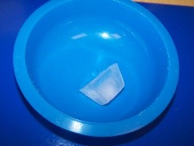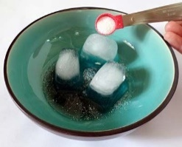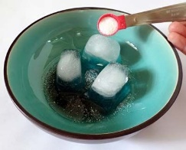
Ice on its own salt sugar flour

- Draw a chart like below to record your findings.
 | 10 minutes | 20 minutes | 30 minutes | 40 minutes
1
2 salt
3 sugar
4 flour

- Check your ice cubes after 10 minutes. If the ice cube has fully melted place a tick in the box. If the ice cube has not melted place cross in the box and wait another 10 minutes. Continue this until the ice cube is fully melted.
- Look at your results. Which ice cube melted the quickest?

Conclusion: did you guess the correct ice cube. What did you find out? Why might you think this happens?

PE
Let’s get moving!
Look for the icon below on the Year 1 home learning page and choose one of your favourites. Cosmic yoga, PE with Joe Wicks, Just Dance or Go Noodle. Make sure you warm up first and then have some fun!



