Year 1 home learning
Monday 18th January
Phonics- 20 mins
Watch the video with Mrs Ryall. This week we’re looking at the phonemes er, ir and ur. See which things Mrs Ryall found around her house. Watch the video and then can you have a go at writing some of the words?

https://www.youtube.com/watch?v=jbdf41-BS4Q&t=4s

Literacy- 45 mins
Look at the phase 3 tricky Words song. Are there some different words that you can add to your tricky word pair’s game!

https://www.youtube.com/watch?v=OrwjbulJry4

Mrs Paxton had a strange dream last night. Have a look at her video to find out what happened!
https://www.youtube.com/watch?v=y9J2OM0zAJo

‘I’m not …’
What is the stick trying to tell us?

I guess we are going to need to speak to the stick and find out some more information. We need to ask some questions to narrow down the choices.
Can you remember any question words? We use some when we are using our colourful semantics.
Who? | What? | Where?
When? | Why? | How?

Can you think of anymore question words?

Don’t forget when we write questions we start with a capital letter and end with a question mark.

Capital letter What are you doing ? Question mark

Task: Think of some suitable questions to ask the stick. Remember to spell high frequency words (tricky words) correctly. Use capital letter. Use question mark.
____________________________________________________________________________________________________________________________________________

Use speech bubbles to write your questions in.

Maths- 45 mins
Quick warm up-play this game

https://www.ictgames.com/mobilePage/funkyMummy/index.html

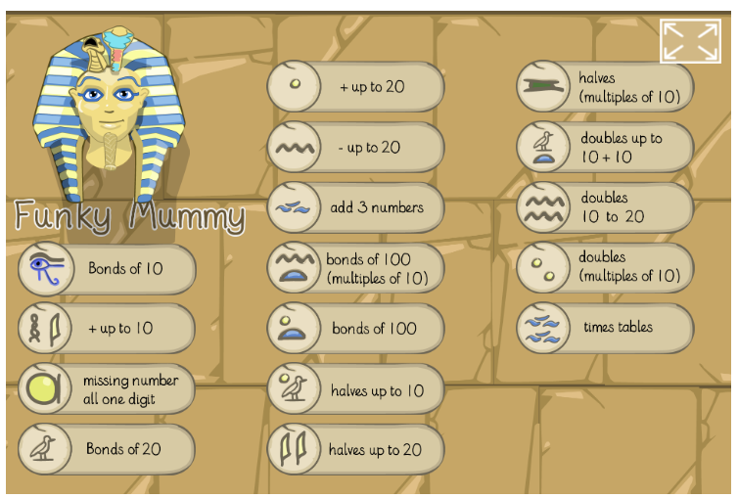

Watch the video in the link below. You will need a pencil and paper to work out some of the problems.

ttps://vimeo.com/490879463

Now you have a try!
https://resources.whiterosemaths.com/wp-content/uploads/2019/11/Y1-Spring-Block-1-WO1-Add-by-counting-on-2019.pdf

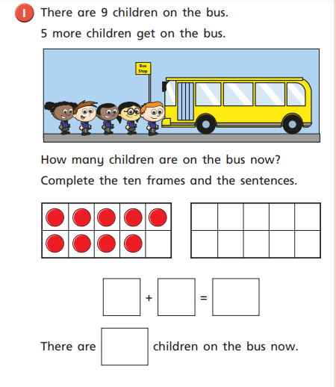

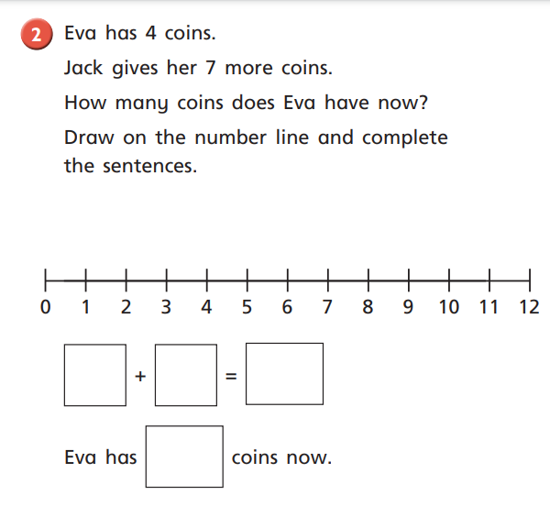

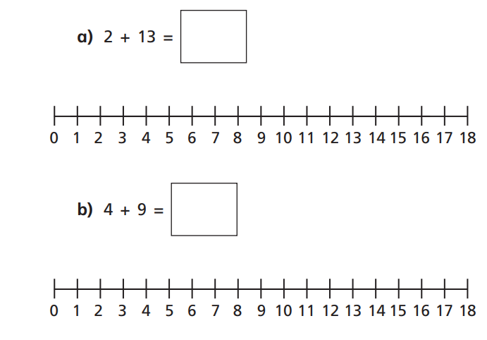

Afternoon learning and activities- about an hour
Science
Task 1:
Exploring the weather.
Have a look at the PowerPoint all about winter.
https://woodrowfirst.sharepoint.com/:p:/r/sites/WoodrowStaff/_layouts/15/Doc.aspx?sourcedoc=%7BB9628D8C-5D9B-406B-9F0F-A67493CC4305%7D&file=all%20about%20winter.pptx&action=edit&mobileredirect=true

Discuss: What is the weather like in winter? How is it different from autumn? What clothes would we wear in winter?

You might want to use a role on the wall to draw and label a picture of what you would wear in winter or you could collect the items at home and take a picture.
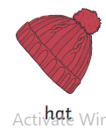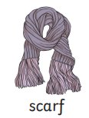

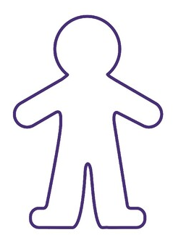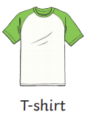
Role on the wall.

You might like to write a sentence. In winter we wear …
Task 2:
What is the weather today?
This week we are going to look at the weather each day. Below I have drawn a table for you and your grown up to copy.

What is the weather like today?

Monday | Tuesday | Wednesday | Thursday | Friday

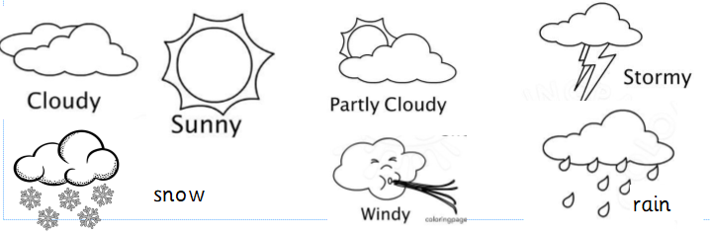Look outside and decide what the weather is like and record this on your table.

PE
Let’s get moving!
Look for the icon below on the Year 1 home learning page and choose one of your favourites. Cosmic yoga, PE with Joe Wicks, Just Dance or Go Noodle. Make sure you warm up first and then have some fun!



