Year 1 home learning
Tuesday 2nd March

Phonics- 20 mins
Watch both of these short videos and see if Geraldine can find words with the aw and au sounds.

https://www.youtube.com/watch?v=7xvdbR6g060

https://www.youtube.com/watch?v=dOHDkQGhku4

Now play ‘odd one out’ with Mrs Ryall. Look at the pictures and see which one doesn’t belong.

https://www.youtube.com/watch?v=9XOlxIYIPtw

Literacy- 45 mins
Practice your long ladder letters.
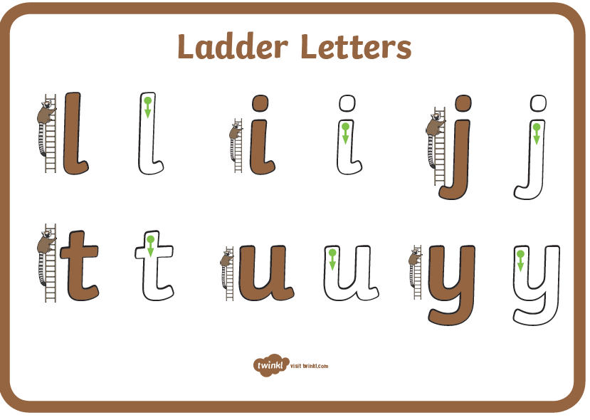
https://www.youtube.com/watch?v=CKqFd2Oz1JY

Look at the story Into the Forest. Take a good look at all the clues in the pictures. Can you spot some traditional fairy tale characters?

https://www.youtube.com/watch?v=qjgugbdwvMY

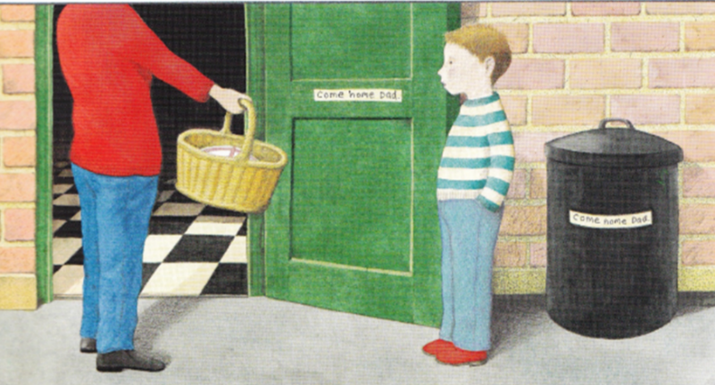
On this page of the story, we see mum handing the boy the basket with cake for grandma because she is poorly. It also says:
I love Grandma. She always tells me such fantastic stories.
In the story the boy meets lots of characters from fairy tale stories that his grandma had shared with him.

Have your grandma’s or nans ever told you stories?
What are your favourite stories?

Fairy tales are exciting stories set in a magical location with a hero, villain and characters that have magical powers. Here are a few characters from some fairy tales.
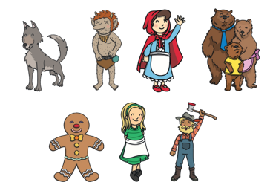

Do you know who are the heroes and who are the Villains? Can you explain why?

Draw the characters from your favourite story. Think about:
- Where the story is set.
- The characters, heroes and villains.
- Special objects.
- Familiar phrases.

Maths- 45 mins
Quick starter!
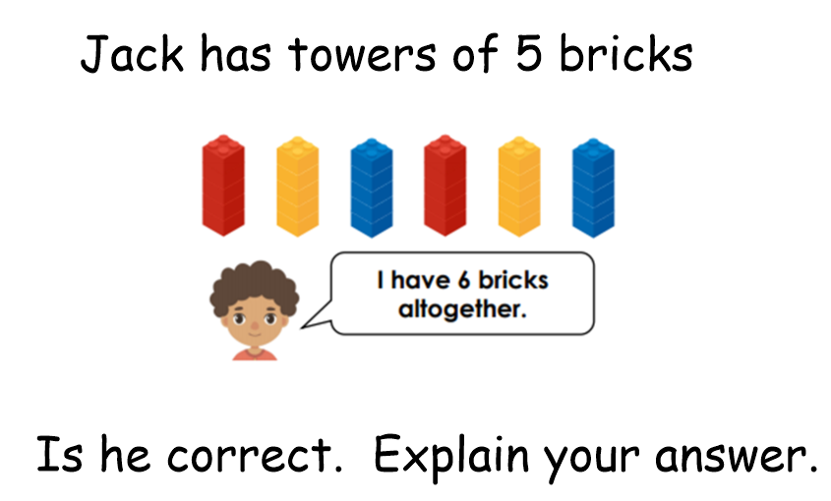

Yesterday we made hands to help us count in 5s. Take your counting in 5s hands out now, mix them up and then see if you can put them in the right order.

Learn how to use counting skills to find the answer to a real-life question by watching the video below.

https://www.bbc.co.uk/bitesize/articles/zhfjqp3

Find some objects that you can count in 5s. Find the answer and then add another group of 5. Can you work out the answer using both ways that were shown to you on the video?

Now you have a go!
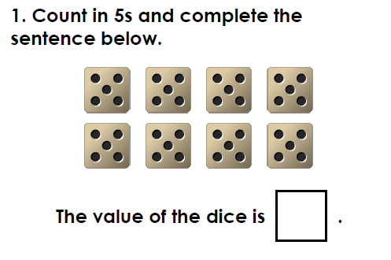
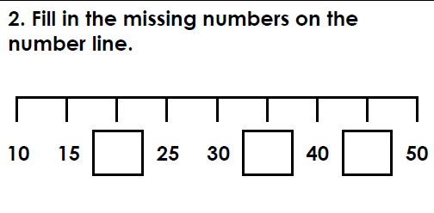

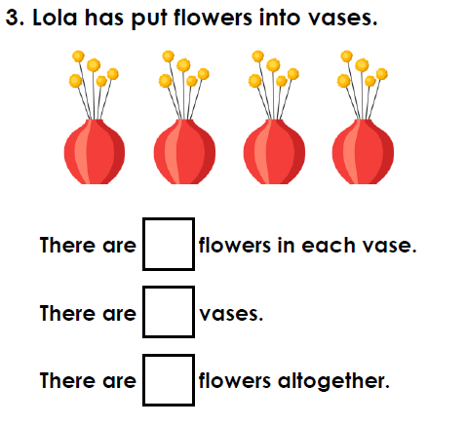
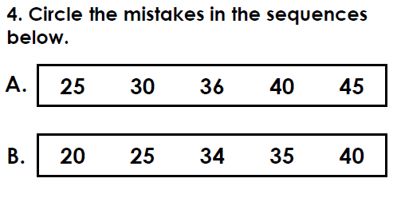

Afternoon learning and activities- about an hour
Spring is definitely in the air! Earlier in the year we asked you to think all about Winter now it’s time to look for clues that Spring is on the way.
Have a look at this video
https://www.youtube.com/watch?v=vLAnt9__5Mg

Did you see all the signs of spring? Have you seen anything when you have been out and about on your walks? Draw a picture and write a sentence about Spring.


