Year 1 home learning
Thursday 14th January
Phonics- 20 mins
Let’s practice our capital letters.
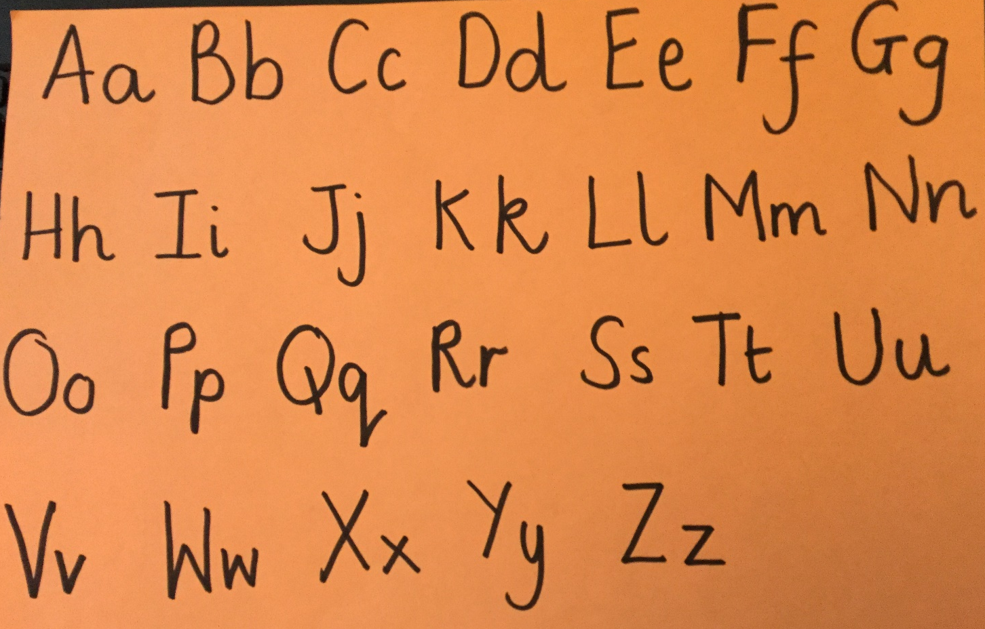
You will need a pen or pencil for this and some paper.
Watch the video and write the alphabet as it plays.

https://www.youtube.com/watch?v=9xSaINX-fdc

Yesterday we were looking at the phoneme ‘wh’. We now know that the sound ‘wh’ always comes at the beginning of a word.
Quick write the phoneme ‘wh’. Get a grown up to count down from 20-0 or use a 1 minute timer and see how many times you can write the phoneme ‘wh’. Make sure the letters are written correctly – remember we never start our letters from the bottom!

Maybe you could try to beat your grown up it they wrote the phoneme as well!

Now play a game with Mrs Ryall?
Watch Mrs Ryall’s video and play ‘Real and Not real’ words.

Here are a list of the words that she used if you want to make them first.
whef | whisper | wh irl
wheck | whaz | whip
wh eel | wh eeb | whek
when | whisk | wh eat
wheg | whem

https://www.youtube.com/watch?v=Yo_V3XwdcUo
Literacy- 45 mins
We have worked hard with the ‘Not a Stick’ story. Think about all the things we have done…

 Found a stick and imagined it was something you could use.
 Drew 10 different nouns ad labelled them (noun is a person, place or thing/object).
 Thought of some characters/people who might have touched your stick before you.
 Learnt all about contractions: I am – I’m

Thought about and learnt positional words – in/on/under.
Where?

Now I think you are ready to write your own poem. We did lots of work on poems in school, so you are already experts. This will be a list poem.
The first challenge is for you to think of 20 things that the stick could be?

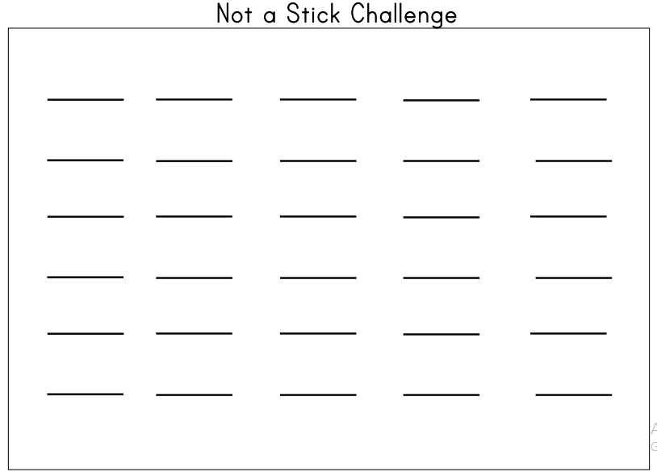
Here is a reminder of what the pig imagined his stick could be:
fishing rod baton paintbrush
bar for weights a horse a spear a sword

Once you have written down all your ideas it’s time to get writing with your poem.

Start you poem with:
This is not a stick …
Then for each line start off with the contraction:
It’s a …
Make your poem as long and as colourful as you can. Why not draw all the things that your stick can be!
This is not a stick …

It’s a magic wand

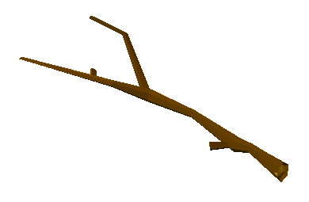
It’s a walking stick

It’s a paintbrush

It’s a horse to ride on

It’s a pole to ski

It’s a sword to swish

It’s a fishing pole

It’s a microphone

It’s a guitar to play

It’s a telescope.

By Mrs Paxton
Maths- 45 mins
Quick starter!
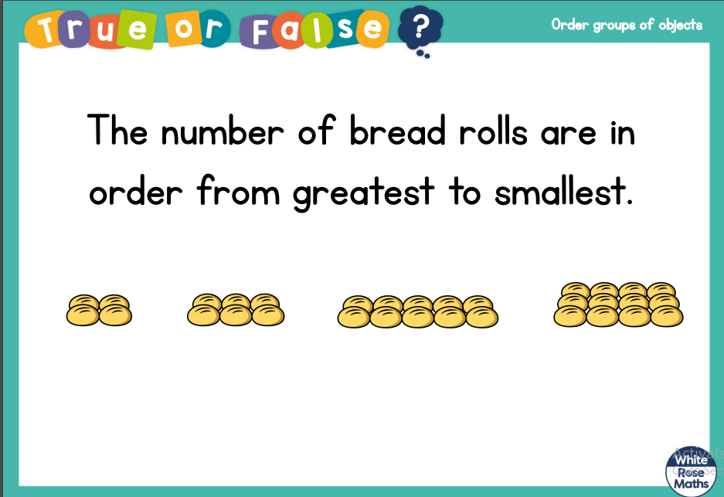

Take your time, remember greatest means the biggest number.
Can you see if the answer is true or false or do you need to count the rolls?
False.
The number of bread rolls are in order from smallest to greatest.

 | 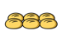 |  | 
4 | 6 | 10 | 12

Answer:

Watch the video in the link below. You will need a pencil and some paper to work out some of the problems.

https://vimeo.com/483537557

Now have a go!
https://resources.whiterosemaths.com/wp-content/uploads/2019/10/Y1-Autumn-Block-4-WO7-Order-groups-of-objects-2019.pdf
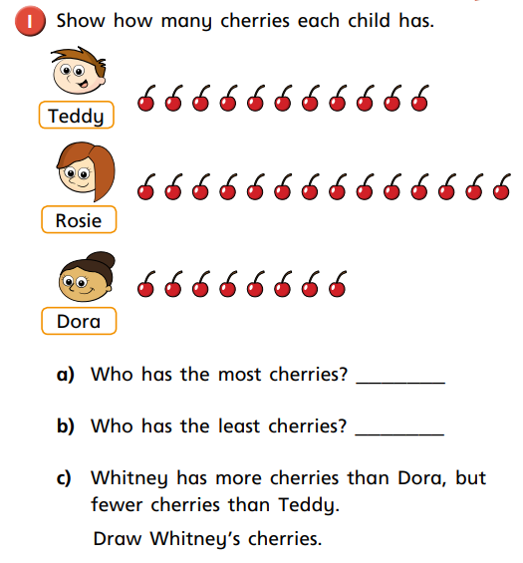

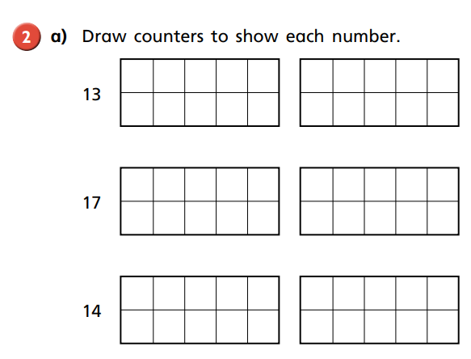

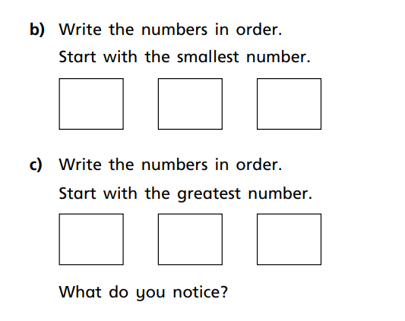

Wow!! You have all worked really hard. Why don’t you help Miss Wilson count some groups of objects and put them in order from smallest to greatest! Then you could have a go with some of your toys or pencils or straws.
https://www.youtube.com/watch?v=xdXSGWNLU3o

Afternoon learning and activities- about an hour
We have been learning about Christians and what they believe in. We have already talked a lot about what Christians think God looks like, what many Christians believe and have listened to some of the stories from The Bible.
Many Christians call Jesus the good shepherd. Below are some examples of art work that show what Christians believe Jesus to look like. Each picture is called the ‘Good Shepherd’.
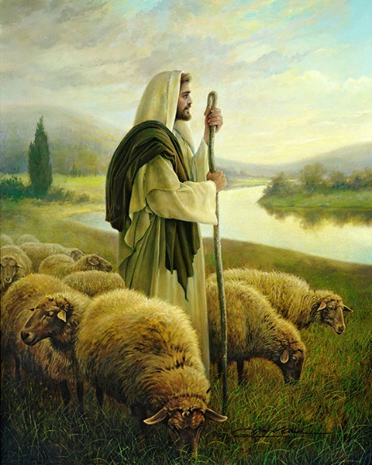
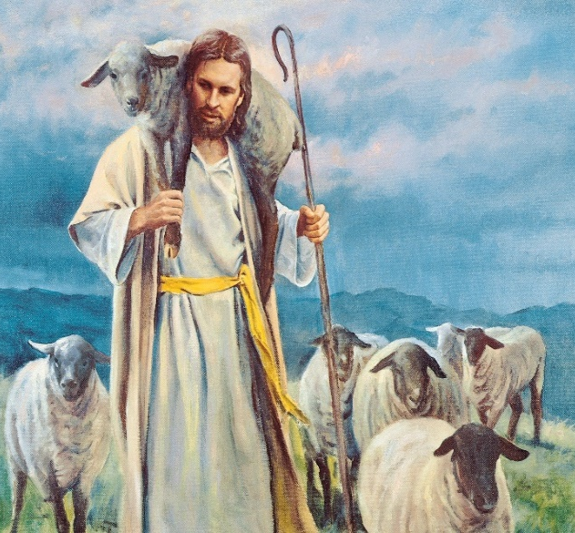
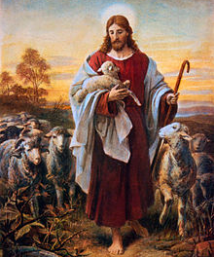

Task 1:
Talk about what you notice in the pictures. You might notice a sheep, or the sky. Talk to you grown up about what you can see.

Task 2:
In the art work, the shepherd is Jesus. Many Christians call Jesus the Good Shepherd. Look at the words below. You might want the print them out and cut them up, or write them on paper.

leader | follower | friend | caring
gentle | man | kind | quiet
good | powerful | listener | loyal

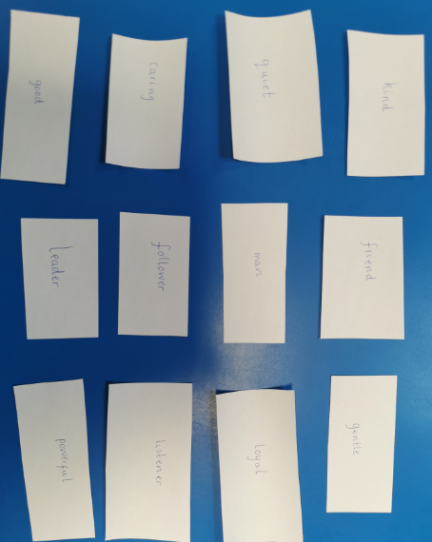
Place the words out and ask an adult the read them to you. I have chosen to write all my words out.

Look at the words you have copied onto paper or printed carefully. Choose 3 words that you think describe you. Are you a friend? Are you kind? Choose 3 to describe you.

Task 3:
Take a look at the words I have chosen to describe Jesus. I used the pictures of the Good Shepherd to help me. Do you agree? Would you choose 3 different words?

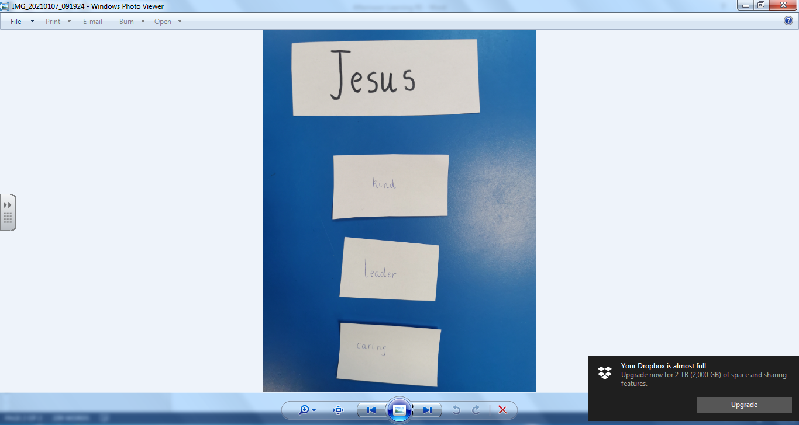
Jesus
- Kind
- Leader
- Caring

I think Jesus is kind because he is helping a sheep by carrying them.
I think Jesus is a leader because it looks like he is leading the sheep, like shepherd do.
I think Jesus is caring because he looks like he is carrying the baby lamb. The baby lamb might be tired.

Why have you chosen your words? What did you notice in the art to help you decide?

Task 4:
We have looked at stained glass windows before in our learning time. Today, we are going to have a go at making a stained glass window, for the story of ‘The Good Shepherd’. Watch the video of Miss Sleem making a stained glass window. When you have finished making yours, we would love to see a photograph.

https://youtu.be/NWlSugpu1Ho

