Year 1 home learning
Thursday 28th January
Phonics- 20 mins
Task 1: Have a go at the dragon's den game.
Click  then phase 5 
and choose the ‘ay’ phoneme 

https://www.phonicsplay.co.uk/resources/phase/5/dragons-den

Okay today we are going to be doing phonics like we would in the classroom. You are all used to doing this activity! Mrs Ryall has got some ‘ai’ and ‘ay’ sentences for you to read. Once you have read them you are going to draw the picture to match. Don’t forget to take your time, pause the video so you can read the sentences and then draw the picture.

https://www.youtube.com/watch?v=VFSAZBYf8WA

Nails painted red. | A snail on holiday. | A dog playing with his tail.
Pots of paint on a tray. | A train in the rain. | Today is Thursday.

If you're finding that phonics task a bit tricky, why don’t you help Mrs Matthews sort the ‘ai’ and ‘ay’ words. Watch the video and get started!

https://www.youtube.com/watch?v=beTDWtCvxRY

Literacy- 45 mins
Let’s practice our one-armed robot letters.
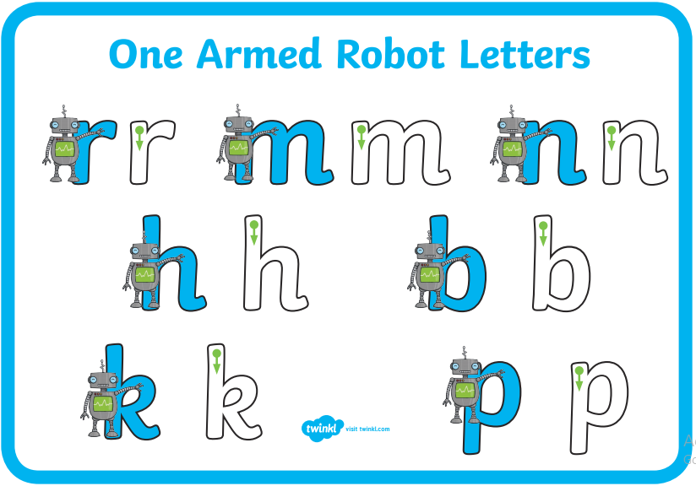

We are going to be thinking about verbs.
What is a verb?
A verb is a word used to describe an action, that's doing something. For example,
Stickman goes out for a jog.
Stickman is floats down the river.

Write down what Stickman is doing in the pictures.
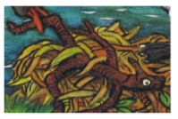
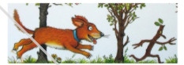
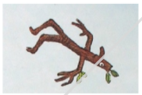
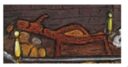
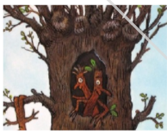
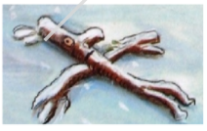

If you want a challenge!

Some of these words can be changed by adding s, es, ed or ing (we call these suffixes). Make a list of all the things that happened to Stickman. When you have made a list of verbs why don’t you see if you can add s, ed or ing at the end of the word? You might want to set it out like this.

Root word | s | es | ed | ing
float
throw
fall
fetch
toss
weave
look
sleep

Maths- 45 mins
Quick starter!
Have a go at this fun ‘fruit splat subtraction’! You can all have a go at level 1 and then have a go at level 2. If you want even more of a challenge, then try a different level. Have fun!

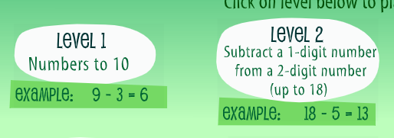
https://www.sheppardsoftware.com/math/subtraction/fruit-splat-game/

Watch the video in the link below. You will need a pencil and some paper to work out some of the problems.

https://vimeo.com/497919464

Now have a go!
https://resources.whiterosemaths.com/wp-content/uploads/2019/11/Y1-Spring-Block-1-WO5-Subtraction-crossing-10-1-2019.pdf

Subtraction crossing 10 – 1
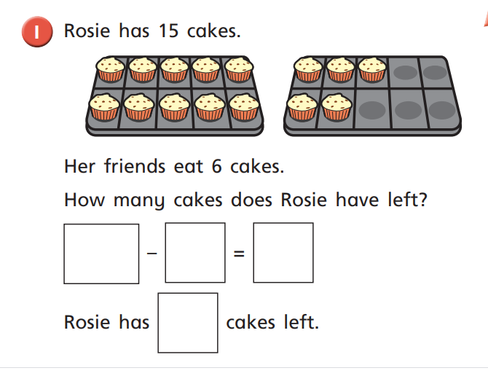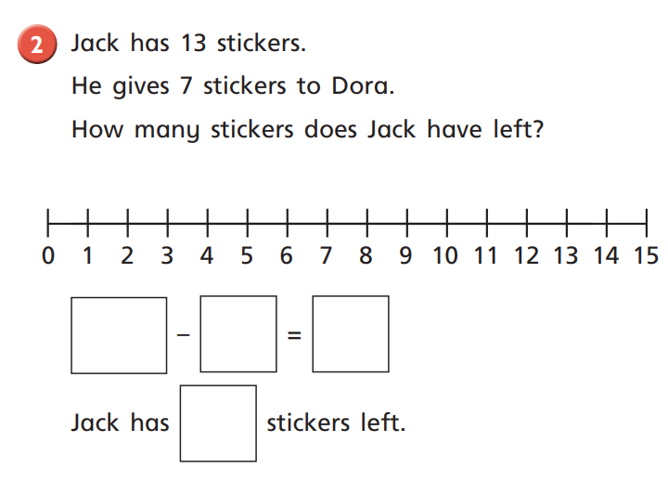

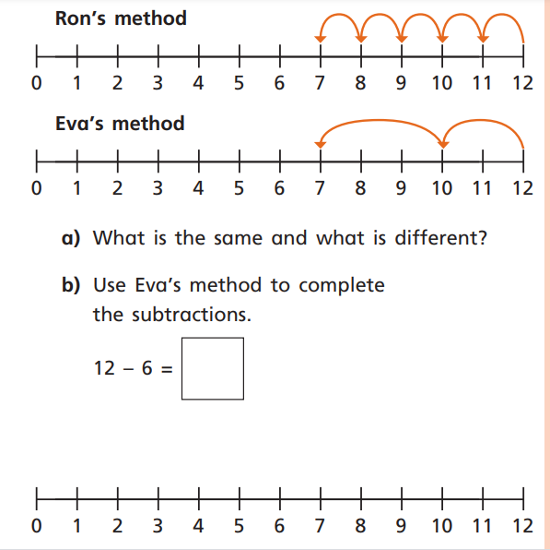

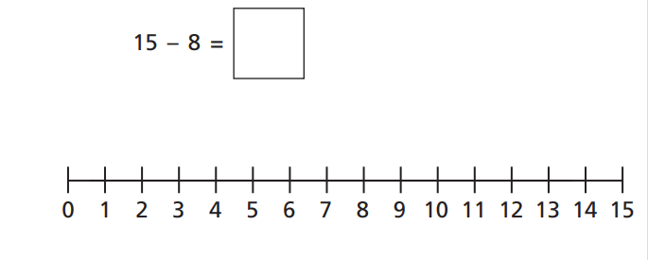
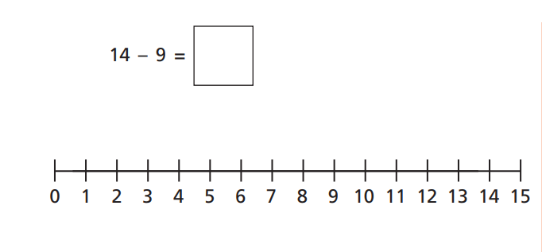

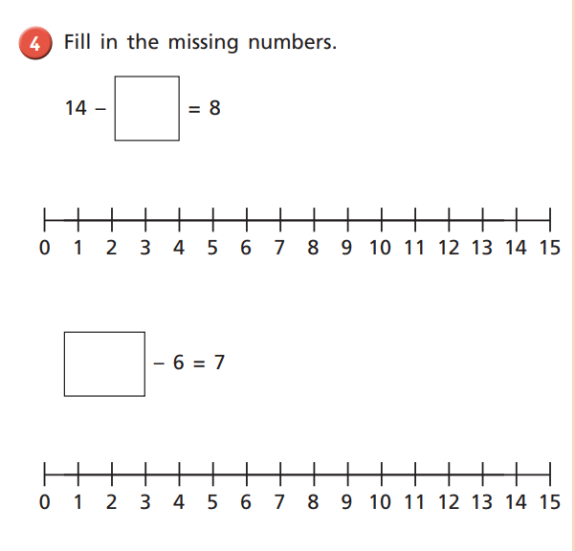

Afternoon learning and activities- about an hour
Art
Last week, we looked at Lowry’s painting ‘The Notice Board’ and we created our own version of this picture.
What do you remember about how we drew the people? What kind of people did we draw?

Session 2: Learning about LS Lowry

Task 1: Find your picture from last week, or use mine. We are going to look at the same and different. Talk about things that seem similar or the same to Lowry’s art and also the things that are different. You could write them on the back of your art, or make a table like the one below.

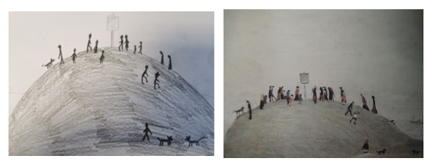
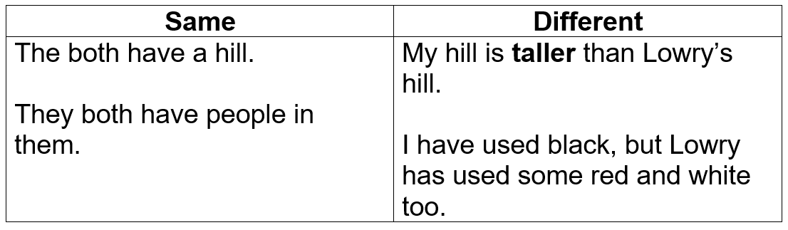
What else can see that is the same and different?

Task 2: Take a look at the painting below. This is one of Lowry’s most famous paintings. It is called ‘Going to Work’.
What can you see in the painting? Make a list of the things that you notice.
I can see:
Buses
Grey skies
People
Clocks
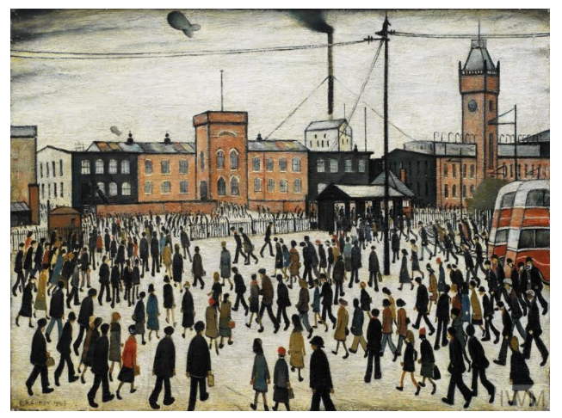

Task 3: Now, today we are only creating the background for this piece of art. You will need,
- A ruler (or a straight edge)
- A pencil
- A piece of paper.
Watch the short video of Miss Sleem, talking through how she has made her background. Remember, no people today, just buildings.
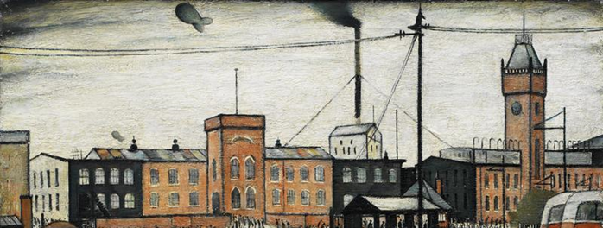

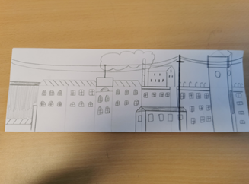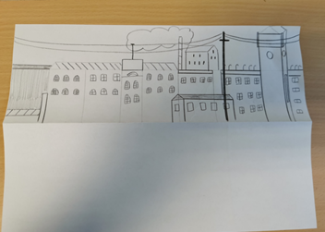

Notes: (please watch the video) Make sure you fold your paper in half, keeping the fold at the bottom of your page. This is going to help us to keep the area for people and detail empty for when we move on to that.
Use a ruler to make a straight line, this will help us to keep out buildings a similar size.
Try and keep all the windows to a similar size. I used a ruler for most of mine, but it is quicker to do them without.

