Year 1 home learning
Tuesday 23rd February
Phonics- 20 mins
Yesterday we looked at the ow and ou sound. Watch Mr Thorne and see if you can read all the ou words that he shows you.

https://www.youtube.com/watch?v=z9NqcU6ccz0

Now watch Mrs Ryall’s video and see if you can sort all the words correctly. Then can you spot which word or picture has disappeared?

https://www.youtube.com/watch?v=XSRhyE9SJeU

Literacy- 45 mins
Practise your long ladder letters.
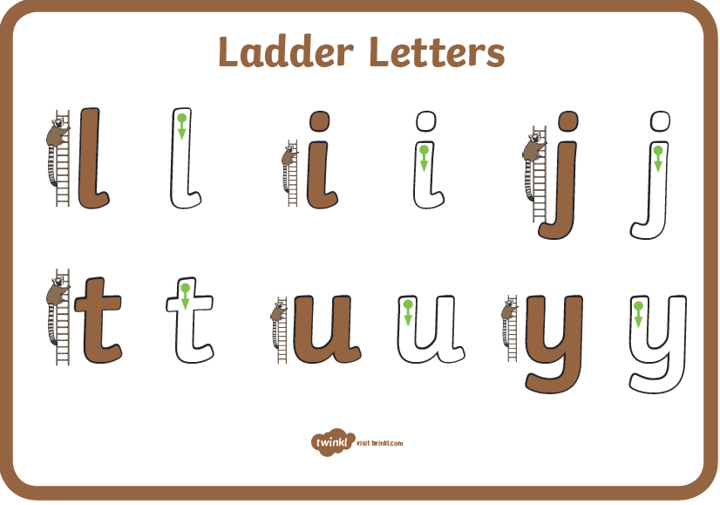

https://www.youtube.com/watch?v=CKqFd2Oz1JY
Okay, take another good look at the front cover. How would you describe the forest? Think about how the picture makes you feel. What do the trees look like? What colour are they?
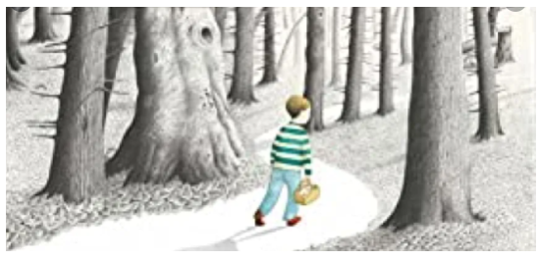

Can you think of some noun phrases to fit into the boxes below? Look at what nouns the arrows are pointing to and describe what they look like, for example:
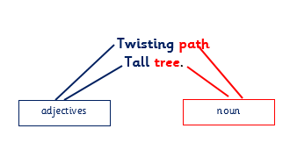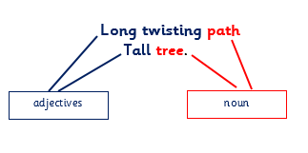

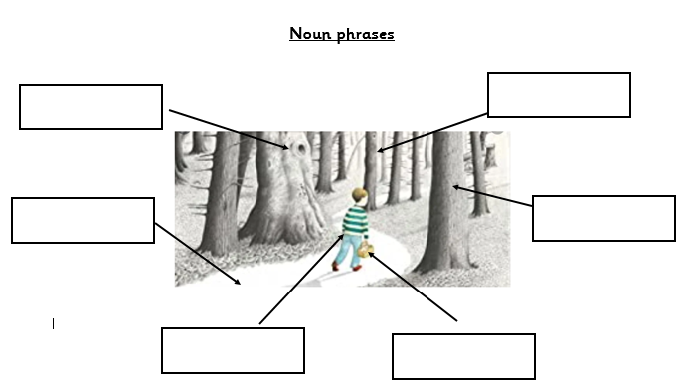
Now using the noun phrases that you have thought of, can you write then in some sentences for example,
The tall grey tree is spiky.
The small boy walks along the twisting path.

Challenge!
See if you can use ‘and’ or ‘because’ to join your sentences together, for example:

The tall grey tree is spiky because the colourful leaves have fallen off.
The small boy walks along the twisting path and he is carrying the heavy straw basket.

Maths- 45 mins
Quick starter!
Which shape in each line is the odd one out? How do you know?
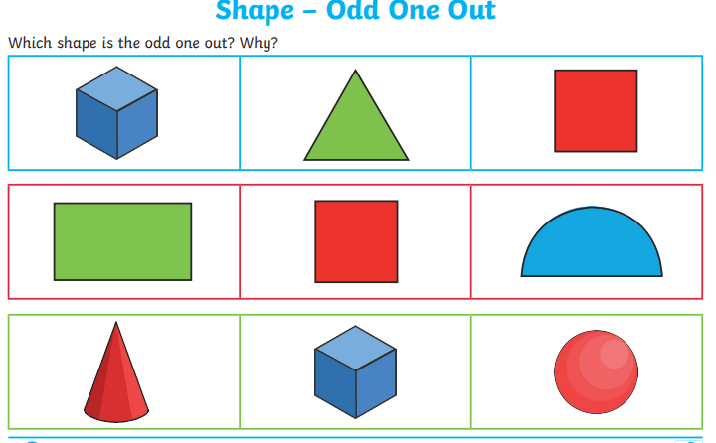

Watch the video in the link below. You will need a pencil and some paper to work out some of the problems.

https://vimeo.com/505658511

Now you have a go!
https://resources.whiterosemaths.com/wp-content/uploads/2019/12/Y1-Spring-Block-2-WO8-Count-in-2s-2019.pdf

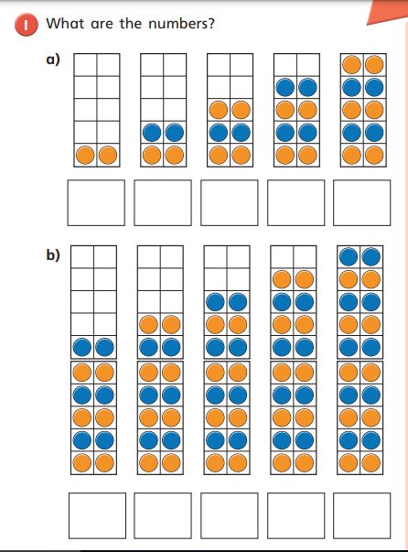

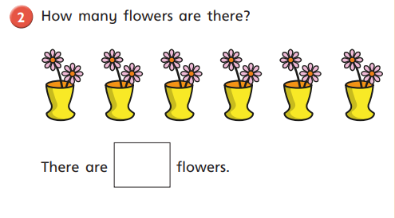
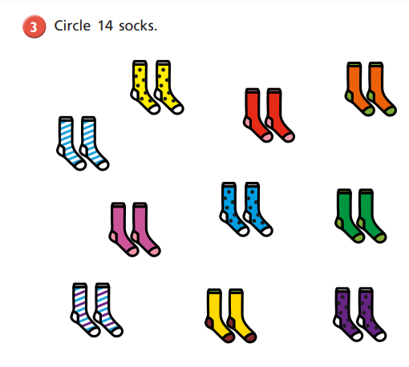
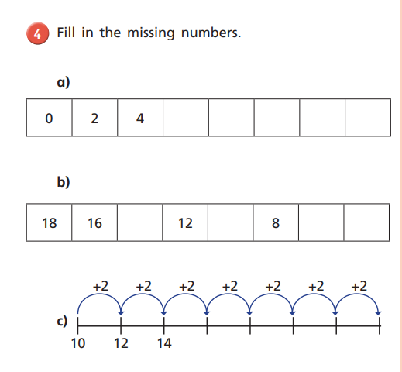

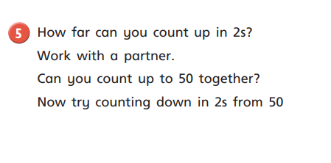

Afternoon learning and activities- about an hour
Yesterday you watched Mrs O’Mahoney and Mrs Matthews sort out mammals, fish and reptiles. Today it’s the turn of the birds, amphibians and insects. Watch their video and see which creatures they found at school.

https://www.youtube.com/watch?v=-NbkkJIjT0c

We’re going to think more about insects today and play a game to help you remember all the body parts a beetle has. To play this game you will need a dice, a pen or pencil and a piece of paper.

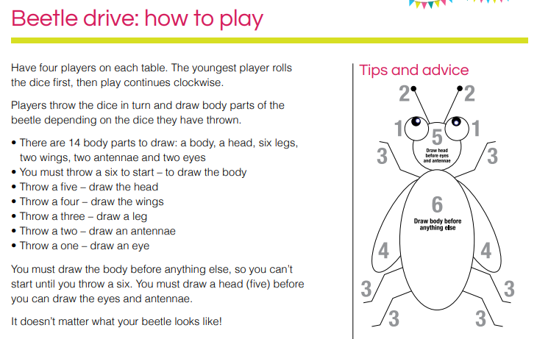

Challenge!
Can you think of a creature for each letter of the alphabet? It could be a bird, mammal, fish, reptile, amphibian or insect.
- alligator
- budgie
- cat
D-donkey
E-emu

Look at these pictures to give you some ideas!



