Year 1 home learning
Tuesday 26th January
Phonics- 20 mins
Look at the phase 3 and 5 flash cards. Shout out the sounds when you see them or press ‘play sound’ button if you are not sure.



We are going on a real and nonsense word hunt with Mrs Paxton. Here are the words that she has hidden.
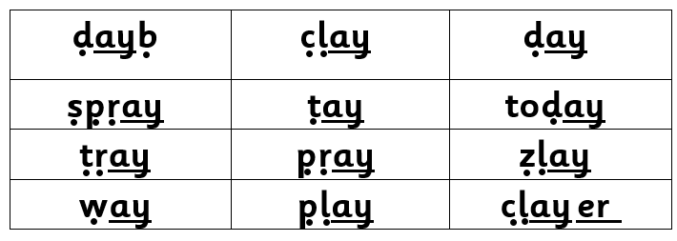

Why don’t you write the words down on separate cards and get your grown up to hide them around your room! Don’t forget only write down the real words (there are 8.)
https://www.youtube.com/watch?v=POv5aTty2S4

If you're not ready for a word hunt yet, why don’t you have a look at Mrs Matthews’ video.

She is showing pictures and telling you the word so you can hear it. Then she is showing you the word, so you can see it. Then she is adding sound buttons so you can write it.
https://www.youtube.com/watch?v=FQjJTDteYQo

Practice your long ladder letters with Mrs Paxton.
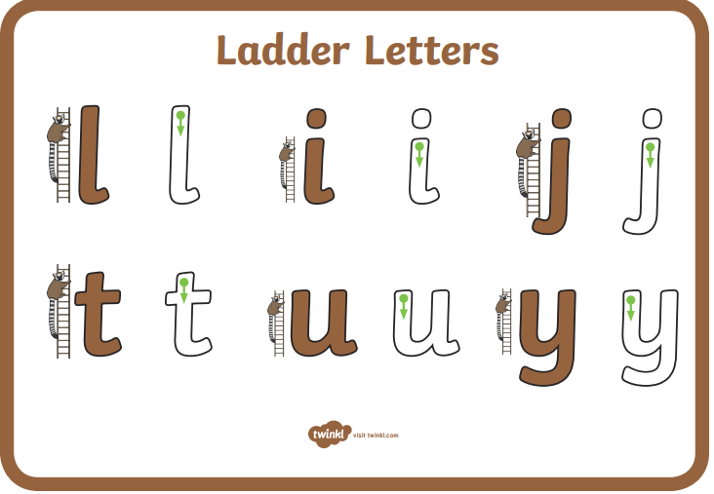

https://www.youtube.com/watch?v=CKqFd2Oz1JY

Literacy- 45 mins
To memorise Stickman story, we are going to look at a story map that Mrs Paxton has made. As we read the story, we are going to be adding some actions to help us remember. Watch the video of Mrs Paxton using the story map to re-tell the story and add actions.

https://www.youtube.com/watch?v=6ZMG4tneUQc

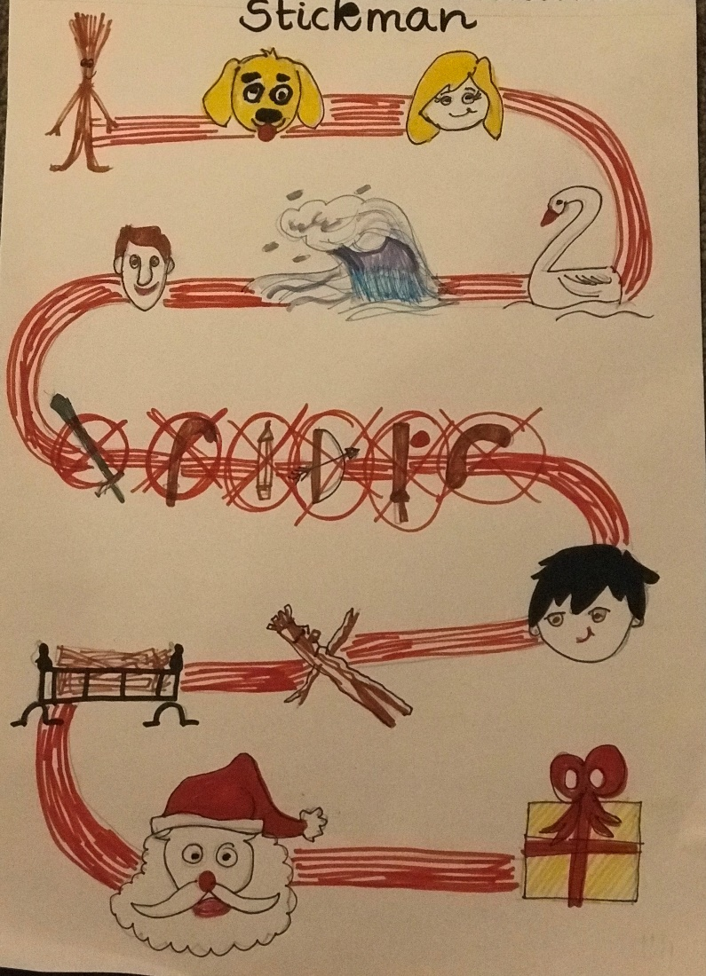

Once you have had a few goes with Mrs Paxton why not try on you own!

Task: Rehearse the story. Use your stick characters to re tell the story with your map from Thursday.
Purpose: to memorise the story.

Maths- 45 mins
Quick starter!
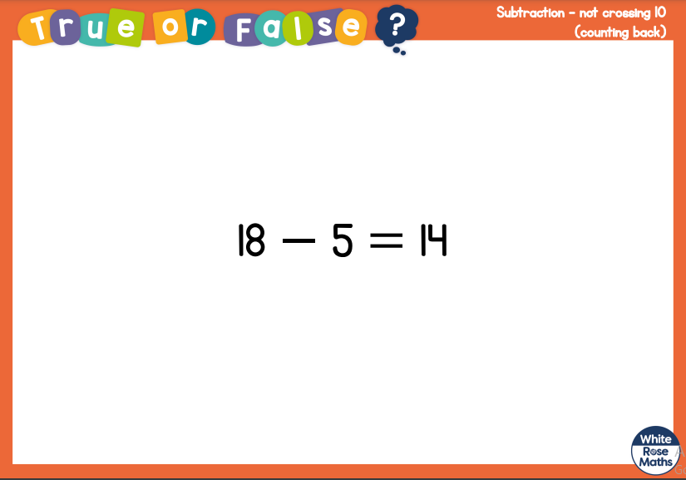

Watch the video in the link below. You will need a pencil and some paper to work out some of the problems.

https://vimeo.com/492198226

Now you have a go!
https://resources.whiterosemaths.com/wp-content/uploads/2020/12/Y1-Spring-Block-1-WO-Subtraction-not-crossing-10-counting-back-2020.pdf
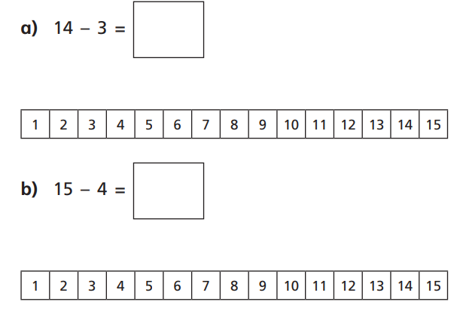
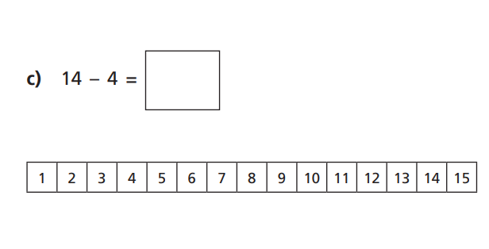

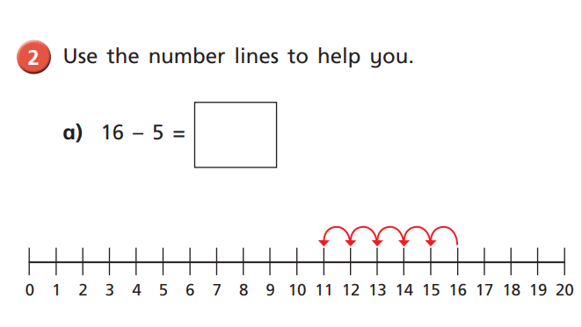
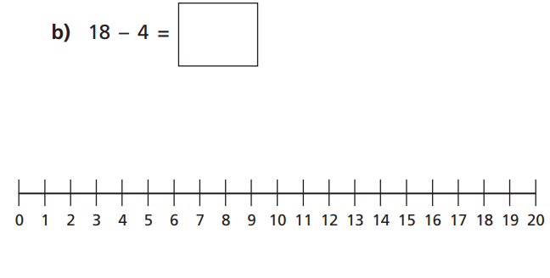
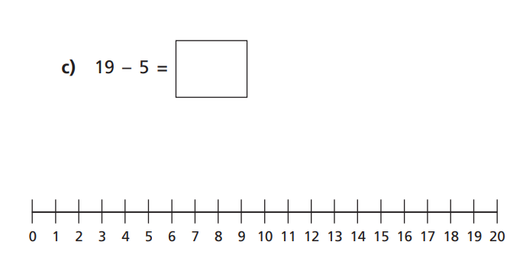

Challenge!
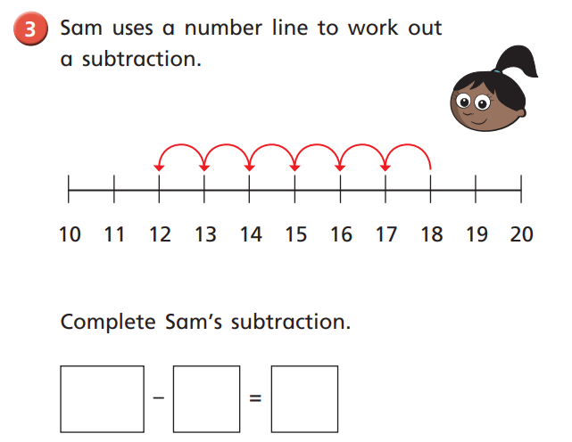

Afternoon learning and activities- about an hour
Science
BBC bitesize: melting and freezing video
https://www.youtube.com/watch?v=BitWextjtzM
snow ice and water:
https://www.bbc.co.uk/bitesize/clips/zpvfb9q

Now it’s time to get your stick man out of the freezer...what has happened to him? The ice is now a solid and stick man is stuck. How are we going to be able to set him free? Now you might be thinking about breaking the ice with a hammer or pouring boiling water onto the ice but I'm worried that this might hurt poor stick man. I wonder if there are any other ways we could melt the ice to set him free?

Yesterday you did an experiment to see what happened to the ice cubes when you put salt, sugar and flour on them. Could you use what you found out to help release stick man from the ice?

How long did it take for you to be able to get stick man out?

Task 2
Now watch the video to show you how to make a book. Now use your book to write down all the information about how you did the experiment.
Don’t forget to send us photos of you doing the experiment, we’d love to see how you got on!

https://www.youtube.com/watch?v=kv9Mka7IGF0

PE
Let’s get moving!
Look for the icon below on the Year 1 home learning page and choose one of your favourites. Cosmic yoga, PE with Joe Wicks, Just Dance or Go Noodle. Make sure you warm up first and then have some fun!



