Year 1 home learning
Friday 15th January
Phonics- 20 mins
Play this game from phonics play choose phase 5
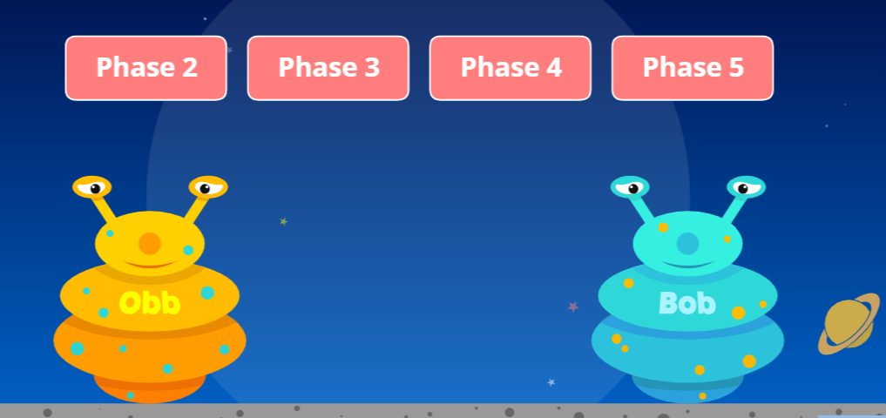
Then choose the ‘wh’ or ‘ph’ diagraph.
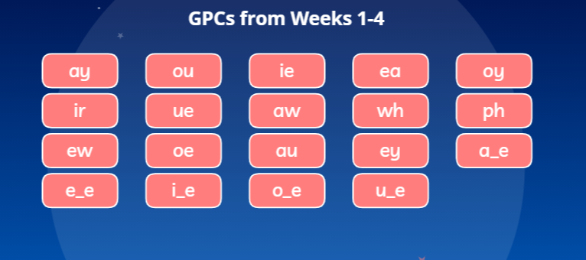

https://www.phonicsplay.co.uk/resources/phase/5/picnic-on-pluto

Read the story below and look carefully for the ‘w, f, wh and ph’ phonemes. Draw a table like below and write down the words that you find! You could watch Mrs Paxton read the story here:

https://www.youtube.com/watch?v=-GKSOoR-G7E

Wendy Witch
Wendy woke up early on Wednesday. She felt like doing some baking. “I’ll just whip up a batch of cupcakes,” she thought. First she had to wash her hands. Then she made the mixture, whisked it, filled the bun cases and put them in the oven. While they baked, she made some white icing. When her cupcakes were finished, she took a photo of the cakes and sent it to her friend Philip. He loved cupcakes, he even won a trophy for the best cupcakes in the village.

w | f | wh | ph

Did you find all the words?
w | f | wh | ph
Wendy  woke  Wednesday  wash | felt  first  filled  finished | whip  whisked  while  white  when | photo  Philip  trophy

Literacy- 45 mins
Look at the phase 3 tricky Words song. Are there some different words that you can add to your tricky word pair’s game!

https://www.youtube.com/watch?v=yM11q1yIdPM

Let’s think about the ‘Not A Stick’ book again. On the first page the author (the person who wrote the story) has written:
‘Hey, be careful with that stick.’
Why do you think they have written this?

Task 1:
Talk to a grownup or someone in your home and tell them all the different things we need to do to keep safe when we are using sticks. See if you can think of 5 things.

So Mrs Bailey, Mrs Heynes and Mrs Tolley have asked us to make a poster for using a stick safely, so our friends in Reception can use them without getting hurt.

You might want to draw on your poster or write some instructions. Make sure your poster has pictures and bold writing.
Don’t throw sticks! 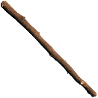
Here are a few things we need to remember when we write our instructions.

Instruction Checklist
Use ‘How to …’ in the title
Time words - First, then, next, after, finally
Numbers or bullet points to show order

Bossy verbs (put, don’t, get)
Short clear sentences
Pictures or diagrams

How to use a stick safely.
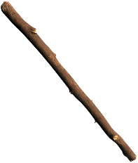
- Find a stick that has no sharp pieces.
- Carry it safely, pointing down to the ground.
- Use your stick outside so there is more space.
- Wave it away from your friends.
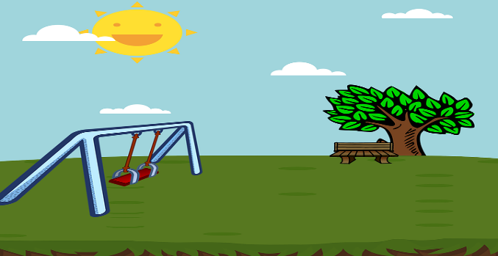
- Don’t poke it in other people’s faces.
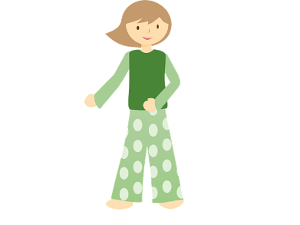

Maths- 45 mins
Quick starter!
Have a go at the ‘Save The Whale’ game. This game needs you to remember your number bonds to 10.
Choose the correct number pipe to make 10 with the first pipe.
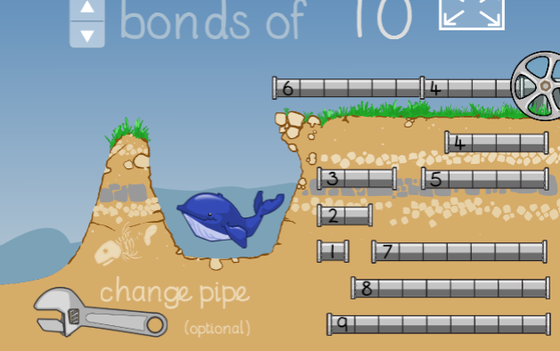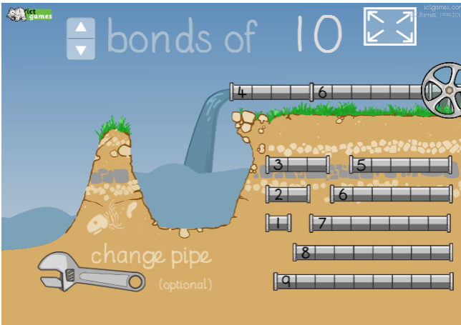
Then spin the wheel to set the Whale free!

https://www.ictgames.com/saveTheWhale/index.html

Watch the video in the link below. You will need a pencil and some paper to work out some of the problems.

https://vimeo.com/483539572

Now have a go!
https://resources.whiterosemaths.com/wp-content/uploads/2019/10/Y1-Autumn-Block-4-WO8-Order-numbers-2019.pdf
Use pasta, straws, pencils or small toys to make 12, 7 and 15
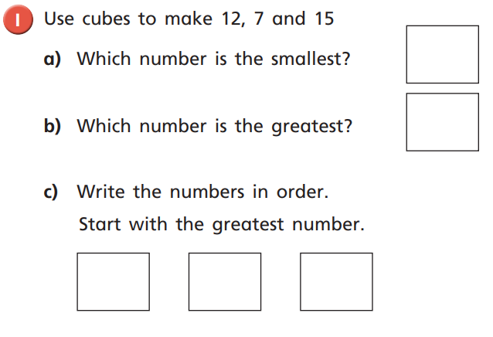

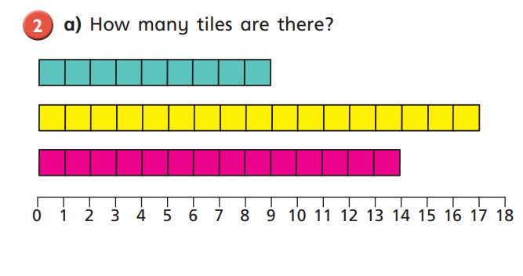
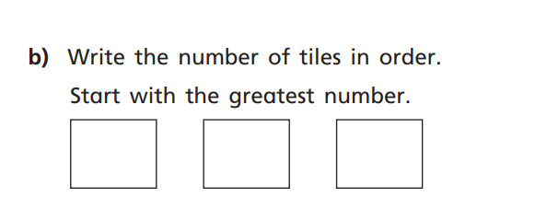

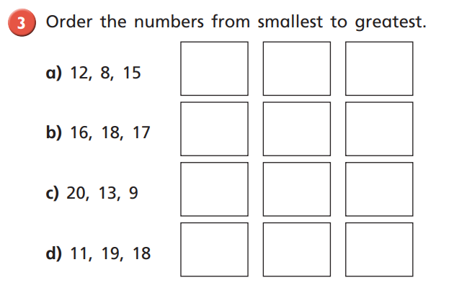
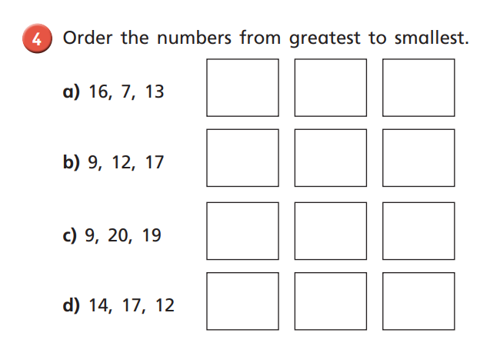

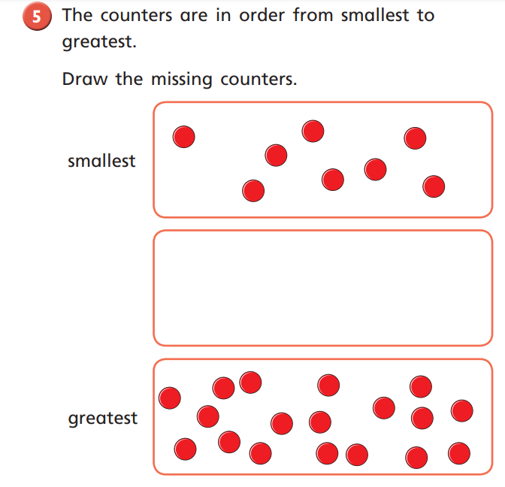
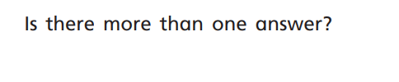

Why don’t you make a ‘Pick a card’ game? Take a look at Mrs Paxton’s video to see how she made her game.

https://www.youtube.com/watch?v=DFEWmskHe0Q
Afternoon learning and activities- about an hour
R.E.
In one of The Bible stories Jesus was asked a question. He was asked – Who is my neighbour?
Task 1:
Who is your neighbour?
On a piece of paper, draw your neighbour.
What is their name? Write their name on your picture.
Talk about what you know about that neighbour. How often do you see them? Have you ever done anything with your neighbour?

Task 2:
Watch the Lego video of The Bible story the ‘Good Samaritan’.

https://www.youtube.com/watch?v=3UkRrAlwOUg

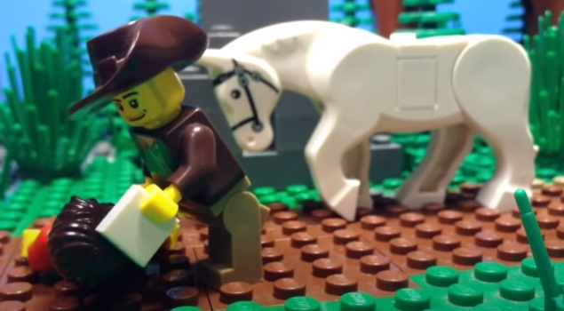
This is the Good Samaritan in this video.

Task 3:
Think of some words to describe the Good Samaritan and make a list. You might start with:
- Kind
- Brave
Think of some other words to describe the Good Samaritan. You might want to look back at the words we used yesterday.

Task 4:
Do you think that the Good Samaritan knew the man who was lying on the floor? What makes you think that?

I noticed that some people walked by the man, lying on the floor. It makes me think that the Good Samaritan didn’t know the man, but he was kind and wanted to help him. What do you think?

Task 5: People
Look at all the pictures of people. Do we know them? Christians tell the story of the Good Samaritan to teach people that we should be kind to all people. When Jesus talks about his neighbour, he means all the people that he meets. He was kind to all of them.

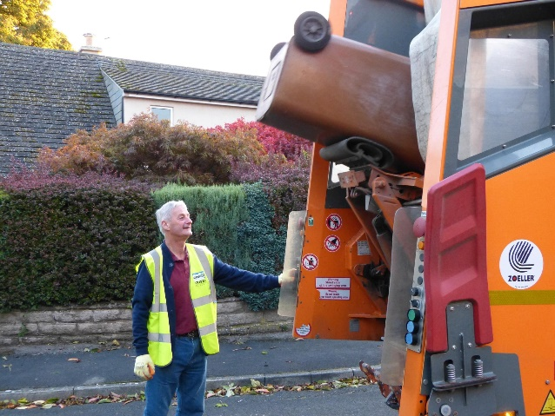

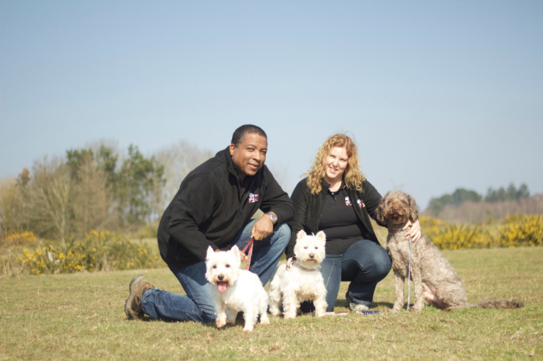

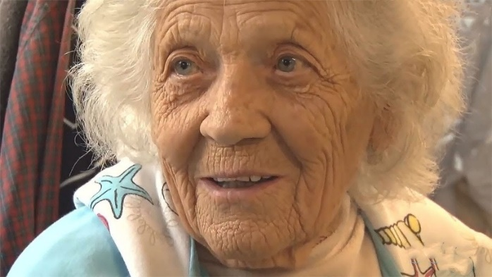

Task 6: Kindness
Today, we are making kindness notes. These are for you to make and hide around the house for your family. You might even want to post one to a family member or a friend. Sometimes, little things make people really happy.
Have a look at some of the ideas below. Can you make some kindness notes or cards? Maybe all the people that you live with could make some for each other.


