Year 1 home learning
Friday 29th January
Phonics- 20 mins
Play this game, choose ay, ai or why not try both? Can you build the words correctly?

https://www.ictgames.com/mobilePage/forestPhonics/index.html
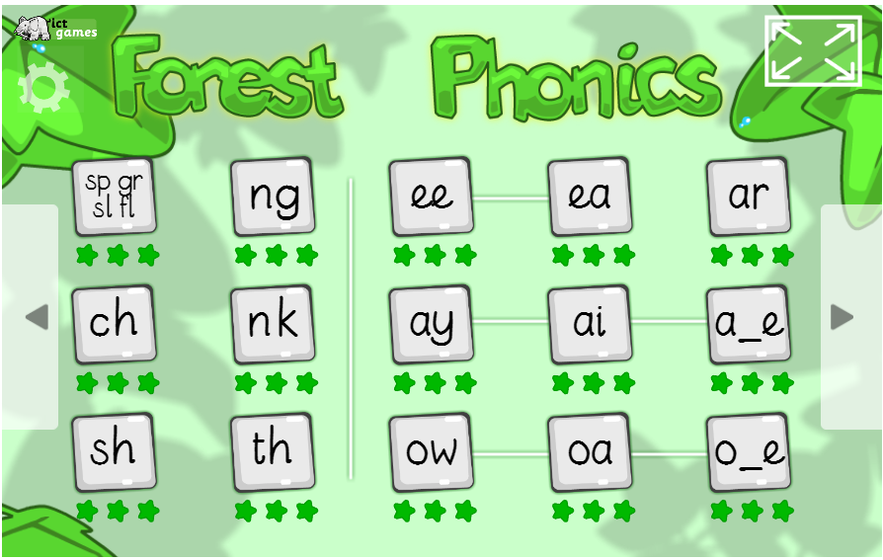

On Thursday you read the sentences and drew some pictures to match, today you are going to have a go at writing some sentences to match my pictures. Watch this video and try your best, remember a capital letter at the start and a full stop at the end.
https://www.youtube.com/watch?v=hUz-lfpVisA

If you find writing sentences tricky then just try to write the ai/ay word in the picture rather than the whole sentence.

Literacy- 45 mins
Do you know what the word emotion means?
(Ways that we can feel)
Have a chat to your grown-ups and talk about all the different emotions that you can experience.
(link to PSHE).

How is stickman feeling?

In the story Stickman experiences lots of different emotions. Take a look at the story again and think about how Stickman is feeling.
“How do you think he feels right now?”
Tell you grown-ups how Stickman if feeling and the reasons why.

Can you show your grown-ups how your face looks when it is happy, sad, angry etc…?

https://www.youtube.com/watch?v=gm5mY5l0Rj4

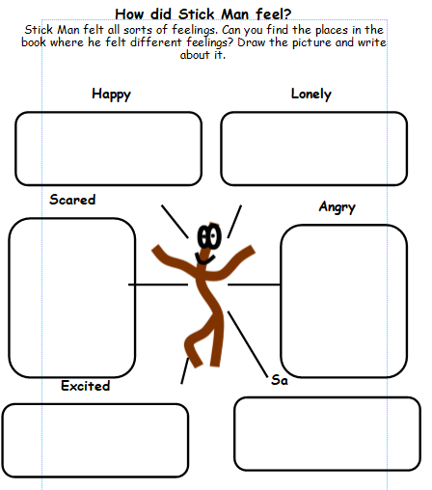

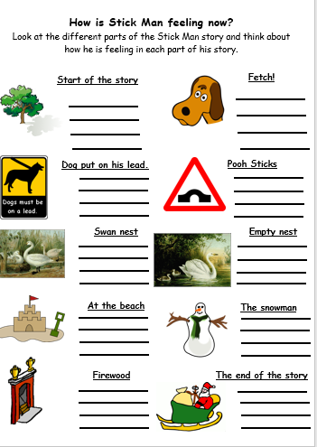

Maths- 45 mins
Quick starter!
https://www.ictgames.com/mobilePage/countingCaterpillar/index.html

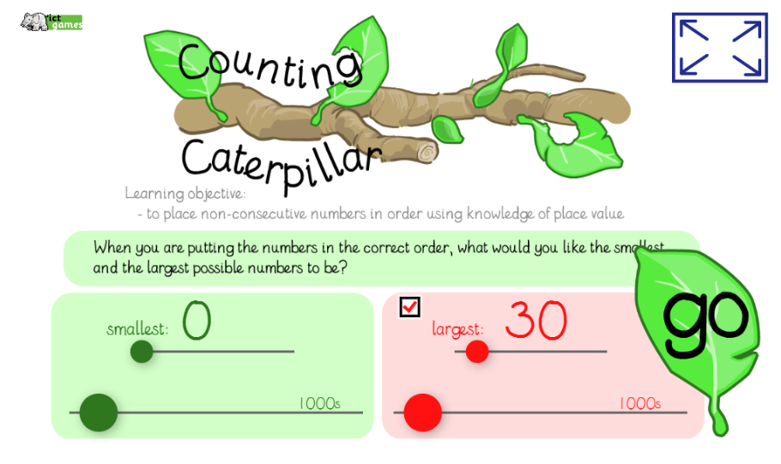
Can you put the numbers in the right order?

Watch the video in the link below. You will need a pencil and some paper to work out some of the problems.

https://vimeo.com/497919984

Now you have a go!
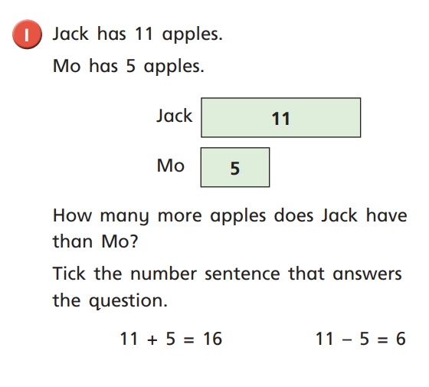

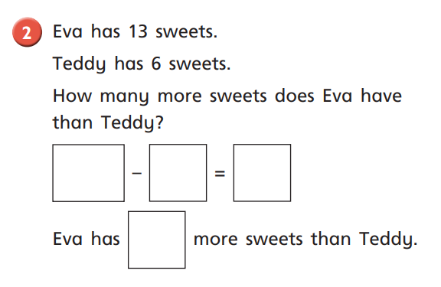

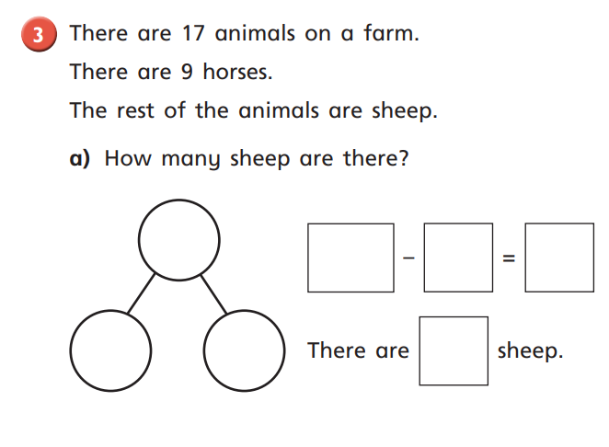

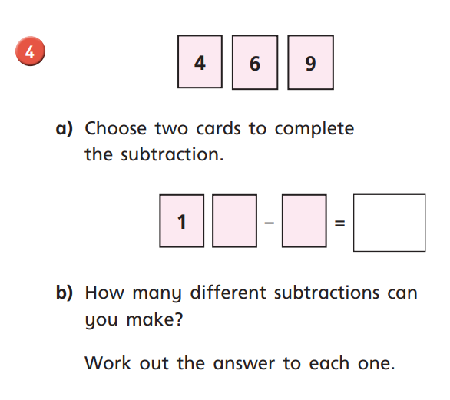

Afternoon learning and activities- about an hour
Art
Session 3: Learning about LS Lowry
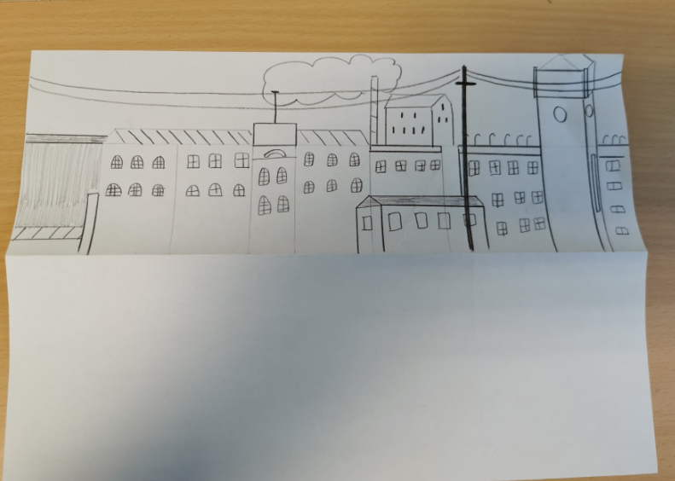
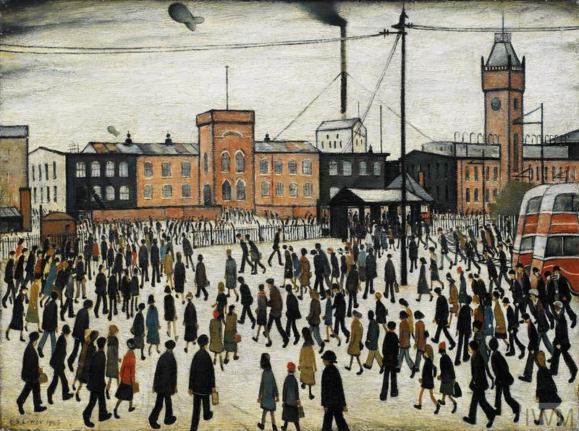

Yesterday, we looked at Lowry’s painting ‘Going to Work’. We focused on line drawings to create the background. We looked at all of the details and tried to add them to our art work. We folded our paper in half, so that we had plenty of space to add people.
Task 1: Find your picture from yesterday. We’re going to explore shading, so you will need a pencil. Take a look at the sky in Lowry’s painting. It seems very dark. There isn’t any sunshine. To shade, we have to hold our pencil differently. Take a look at the picture steps below to add the shading to the sky.

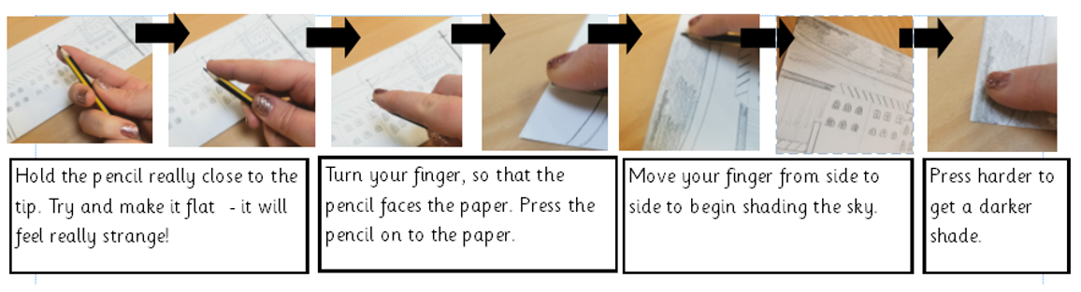

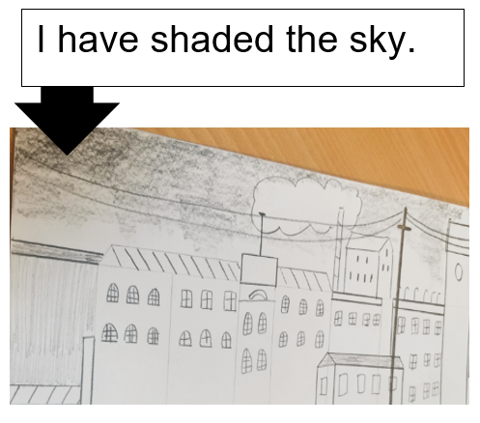

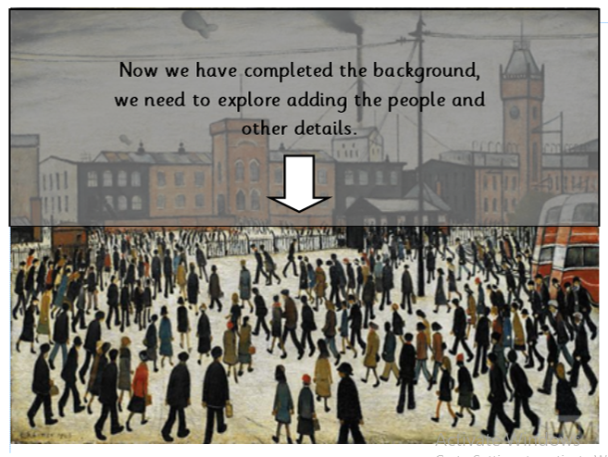

Task 2: Adding detail.
Watch the video to see where we have added more detail, for example, the bus, the telephone post and the fence. Once you’ve added that detail, begin adding more people to your drawing. Remember, it is a very busy walk to work, you need lots of people in the picture. I wonder who will draw the most people on their work.
https://youtu.be/J2VpR3LLSfs

Task 3: Adding groups of people.
Watch the video of how to add groups of people, quickly into your picture. Lowry deliberately made this piece very busy, to show what it was like on the way to work. See if you can try this technique, to create groups of people in your art.
https://youtu.be/PU4WpX7kUso



